**Xeonic Fleet**

Game Design Document

# Table of Contents

**Table of Contents** **2**

**Summary** **3**

Unique Features 3

MVP (Minimal Viable Product) 4

**Story** **4**

Narrative 4

Character 5

Setting 5

**Gameplay** **6**

Design 6

Mechanics 6

SF-13 6

Upgrade 7

Laser 7

Top Gun 8

Homing Lazer 8

HOLD 8

1UP 9

Enemies 9

Flyer 9

Assaulters 9

Striker 9

Shooter 10

Ranger 10

Barrium 10

Dragoon 10

Lazlink 10

Bosses12

XM-4 “CANCER” 12

XM-17”TITAN” 12

XM-33”DRAGOON REX” 13

General Flag Ship 13

**Level Design** **15**

**Art design** **35**

**Sound 49**

**2-Player Option 49**

**Development Plan 50**

# Summary

This Game will be a horizontal side-scrolling space shooter game in which the player tries to complete each level while also trying to obtain a high score.

This will be a playable game in the Main Arcade Dream game.

[<Link to Arcade Dream Design Doc>](https://docs.google.com/document/d/1Fh1FsN2_J-OcjyJvD1ss-3hdCnPutHxBKkPFkc85DL4/edit?usp=sharing)

## Unique Features

## 

## MVP (Minimal Viable Product)

A playable user ship that can shoot and destroy objects and enemies with various weapons (obtained from upgrades) as well as be destroyed itself. The game itself needs to have a level with enemies and objects that have predetermined spawn points and behaviors as well as a boss signifying the end of the level. Each enemy gives a player points to their score as does completing the level, however the player has limited tries until they either complete the level or run out of these tries.

# 

# 

# Story

## Narrative

In the far future, humans have left the Earth and inhabited moving space colonies. However, their travels have met them with another intelligent race, the Alfeons, which they find the humans dangerous. Soon, conflict breaks out as the Alfeons chief nation (Xeon) declares war on humans. This sets the stage for the game.

## Character

You take the role of a pilot of the SF-13, the latest of space fighter of the Earth remnants. You are tasked with engaging the Xeonic Fleet, a vast arsenal of artificial machines hell bent on wiping out you race of space nomads. You main objective is to reach and destroy each wave’s general and force the Xeon’s to cease fire.

## Setting

Every fight is within deep space as you try to engage the enemy. You eventually meet with ruins of previous battles as well as asteroids and other space like objects.

# Gameplay

## Design

The player starts on the left side of the screen as the game auto-scrolls. The player can move around the play space with the only limitation is that they can only be on screen (cant advance\regress the screen) and they will only face forward (no turning or spinning). In the level is various enemies and obstacles that are pre planned in which the player will interact with or avoid. Enemies will spawn from non-visible points while obstacle will be set up already. At the end of a level, a boss character will appear that the player needs to defeat in order to end the level. Once defeated, the player will see their score, then advance to the next level or if they finished the last level, they will be presented with a victory screen and their username will be saved with their score (if they are in the top ten scores, their score and name will be listed). If a tie occurs, the player who obtained the score first will keep their place and the new player with the score will be the next place (dropping all below one including eliminating the tenth best score from view).

## Mechanics

### SF-13

The player character. The player can move the ship with the directional keys (self-explanatory). The player fires weapons with various keys (mentioned in upgrade objects). The standard fire is with the f key, which fires a single projectile per press. The player can obtain upgrades in the game which attaches new weapons or additional features to the existing ones. If the player touches anything (either projectile, enemy, terrain), the player will be destroyed. The players weapon projectiles do not harm ship, so no worry avoiding one's own shot.If the player has remaining tries, they will respawn of the left with base weapons, or if they have none, the game will end.

### Upgrade

These are objects that appear in the game when the player encounters a weapon rock (a small rock that shines indicating its special). If the rock is destroyed, a randomly generated item will appear that the player is allowed to touch without being destroyed. The object will be one of 5 upgrades, which will affect the attribute of the ship. Once an upgrade is obtained, it can not be obtained again unless the player’s ship is destroyed (or when noted). Upgrades are maintained until destruction of player, even between levels.

### Laser

Upgrade item that gives the player a secondary laser weapon. The weapon is fired by pressing the d key, which fires a laser straight ahead. However, holding the d key allow the player to charge the shot. For up to 3 seconds, one can charge and then fire a wider shot (based on charge) on screen. The laser shot also gets stronger when charged (which is helpful when engaging bosses, which require multiple hits).

### Top Gun

Upgrade item that gives the player an additional fire to the ship. The projectile will be at a higher position than the main fire and behaves the same way (press f to fire).

### Homing Lazer

Upgrade item that give the player a homing laser. Once the s key is pressed, the ship fires a laser that goes to the nearest enemy (or boss) and attacks. This will be set up with an AI to have the laser go to the nearest enemy. Note that only one homing laser can be fired on screen at a time, and needs to be offscreen to its fired again. The laser will disappear after 3 seconds of firing. During that time it will go after any enemy and destroy any it touches.

### HOLD

Upgrade item that enables rapid fire for the main fire. Once equipped, the play can now hold f to rapidly fire the main shot. This feature also applies to the Top Gun as well (since they are mapped to the same key).

### 1UP

Upgrade item that gives player additional try in game. This adds one try to try total which carries over to all levels unless try is lost or game is completed. This is the only upgrade that can be obtained more than once, and the only one that appears if the other four upgrades have been obtain on a single try.

## Enemies

### Flyer

Standard enemy type that begin from spawn and swoops in to screen then goes straight. Moderate speed of flight.

### Assaulters

Attack ships that oscillates on screen. Moderate speed.

### Striker

Ship that locates player and attacks (ai based like homing lazer). Slower speed.

### Shooter

Enemy ship that enters screen then shoots projectile. Exits screen after shot. Medium speed.

### Ranger

Enters screen at high speed across most of screen then retreats back. High speed.

### Barrium

Shield enhanced enemy. Requires either laser shot or homing shot to destroy (or a real lucky standard shot). Slow speed across the entire screen.

### Dragoon

Long enemy that sprawls across screen. Sections of the enemy are destructivable and will exist on screen to either all are destroyed or exit the screen. Medium speed.

### Lazlink

Two enemies facing each other that generates a laser line between each other. Will destroy player until one is destroyed. Slow speed.

Obstacles

Rock Plains

Various shapes of rock terrain floating in space. The player is tasked to avoid these or else be destroyed.

Colony remains

Remains of destroyed colonies. Follow same interactions as the rock plains.

Asteroids

Destroyable objects that fly/exist of screen. No points added if shot down.

Line Gear

A circular undestroyable object that generates lines that impede (destroy) player. The lines spread out then spread form lines, only 6 lines total per gear at a time.

Arrow Mace

A worm like machine that wiggles on screen attached to some terrain. The player can fly through the body of the mace, but not the arrow portion.

Lazer Maze

A preset grid of laser that the player needs to be in safe zones to avoid harm. Will be on screen for a few moments then disappear. A diagonal shape for the grid and the safe zones (diamond like).

Bomb

Unused enemy bomb from previous battles. If shot, explosion will occur, destroying player if they can't avoid it.

Blade Rings

Rotating rings that harm player if they can not pass through opening. The player will pass through as long as the ring portion is parallel with the screens “y and z” axis (you can only see the side of the ring on screen, not a ring shape).

## Bosses

XM-4 “CANCER”

The first boss of the game that appears at the end of stage 1. It is a crab shape enemy that appears on screen and attacks the player. It has blade arms that closes and opens. When it opens, the player can go inside and attack its mouth shaped weak point. The boss requires damage of 300 to destroy. When it is destroyed, it will explode (the explosion wont hurt player) and the level clear will appear.

XM-17 “TITAN”

The boss of stage 2. A humanoid robot similar to the Barrium, it will have legs, arms, chest, and head sections. To destroy the boss, one must destroy the chest section, which has 300 damage. However, it has a shield held up by its arm sections. It does lift up the shield allowing damage but it also fires a laser after 2 seconds of being lifted, and after 2 seconds of fire ceased, it will lower its shield. Its head and leg sections also fire weapons (head fires standard projectiles and legs fire new type of weapon, missile, which tries to locate the strike player). To deal with this, these two sections are destroyable, each having 200 damage. When these are destroyed, they blow up leaving the remaining parts intact (it can no longer use the weapon from that section). If the chest is destroyed, the whole boss blows up and the level is complete.

XM-33 “DRAGOON REX”

Boss of the third stage (Dragon head shaped), it is set on the terrain of the third stage and it can lean back and forth. In leading forward, its mouth opens and allows player to attack its weak point (500 damage). In this mode, it fires missiles from its back that act like TITAN’s. In lean back mode, it mouth closes (preventing damage from player) and it has a new attack, a flame emitting from its nostrils. It has a magnet on its head to messed up players controls when near. Note their will also be a laser from the top of the level that the player must also avoid (two second fire occasionally). Once destroyed, the boss blows up and the level clears.

### General Flag Ship

A large battleship that holds the general of Xeon. This ship is massive and contains large amount of ways to harm the player. It has cannons on its top and on its two wings that fire projectiles. It contains a bottom and front laser cannon to deter player. It can also spawn three enemy types from certain locations (barrium, flyer, and striker). It has four sections that need to be destroyed: its two bottom wings, the bridge, and the ship body it self. When everything (except the body) is destroyed, that section blows up (the body will flash when its health has reached zero, indicating to player to not focus on it anymore). The bridge has 300 health, the wings 600 each, and the body has 1000.

Scoring

The scoring in the game comes from destroying the enemies and completed each stage. The scoring amounts are shown below:

Flyer- 50 points

Assaulters-75 points

Striker-100 points

Shooter-150 points

Ranger-100 points

Barrium-250 points

Dragoon-300 each section

Laz Link-250 each section

Stage 1 Clear-20000 points

Stage 2 Clear-40000 points

Stage 3 Clear-75000 points

Stage 4 Clear-125000 points

# Level Design

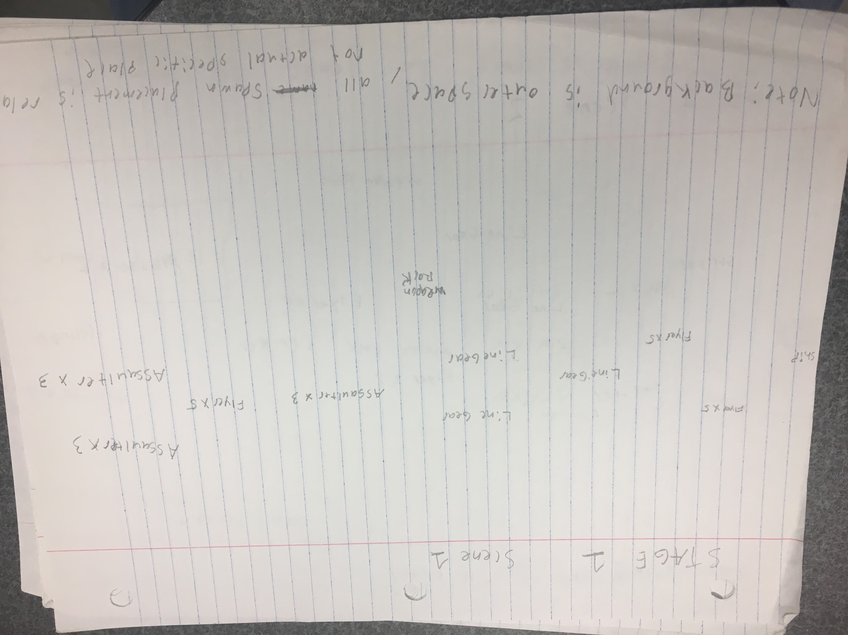

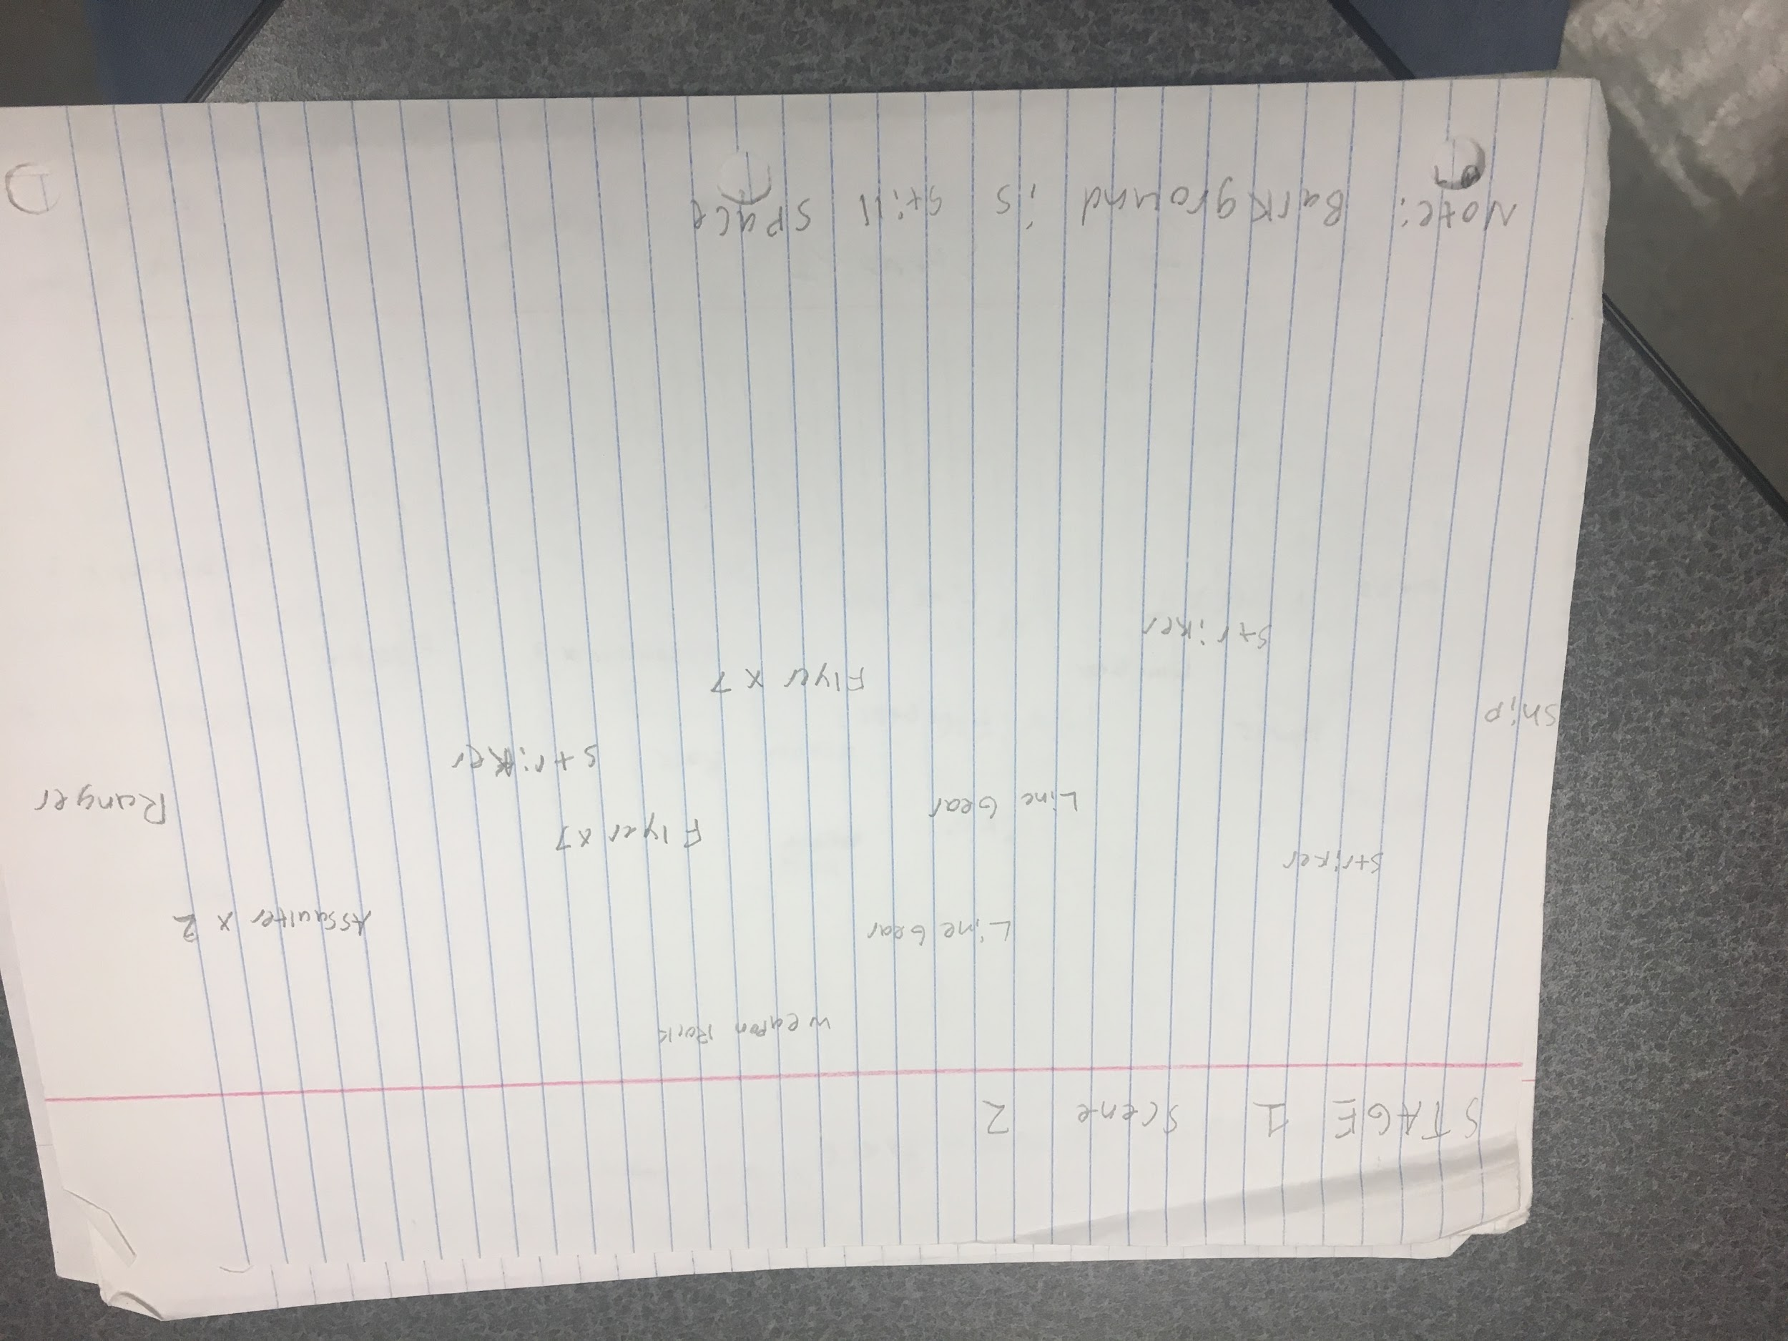

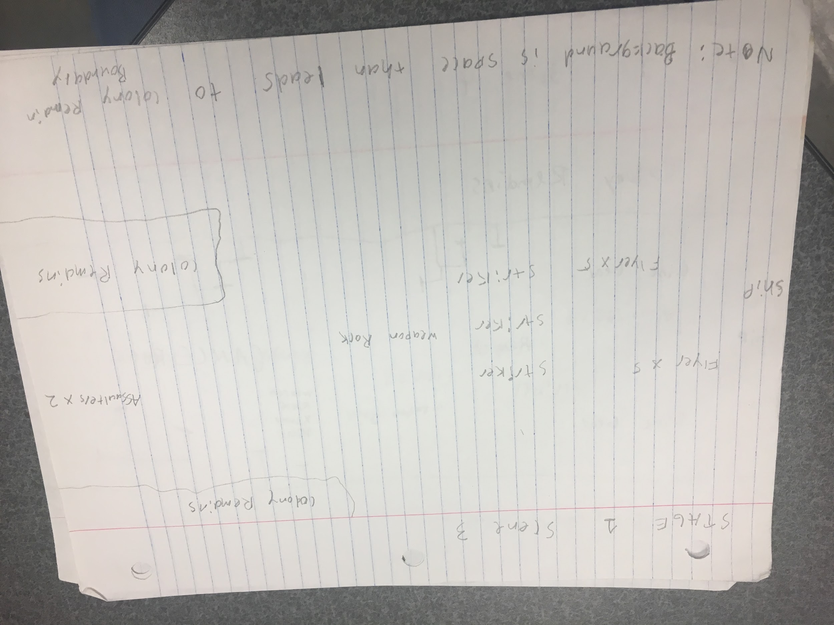

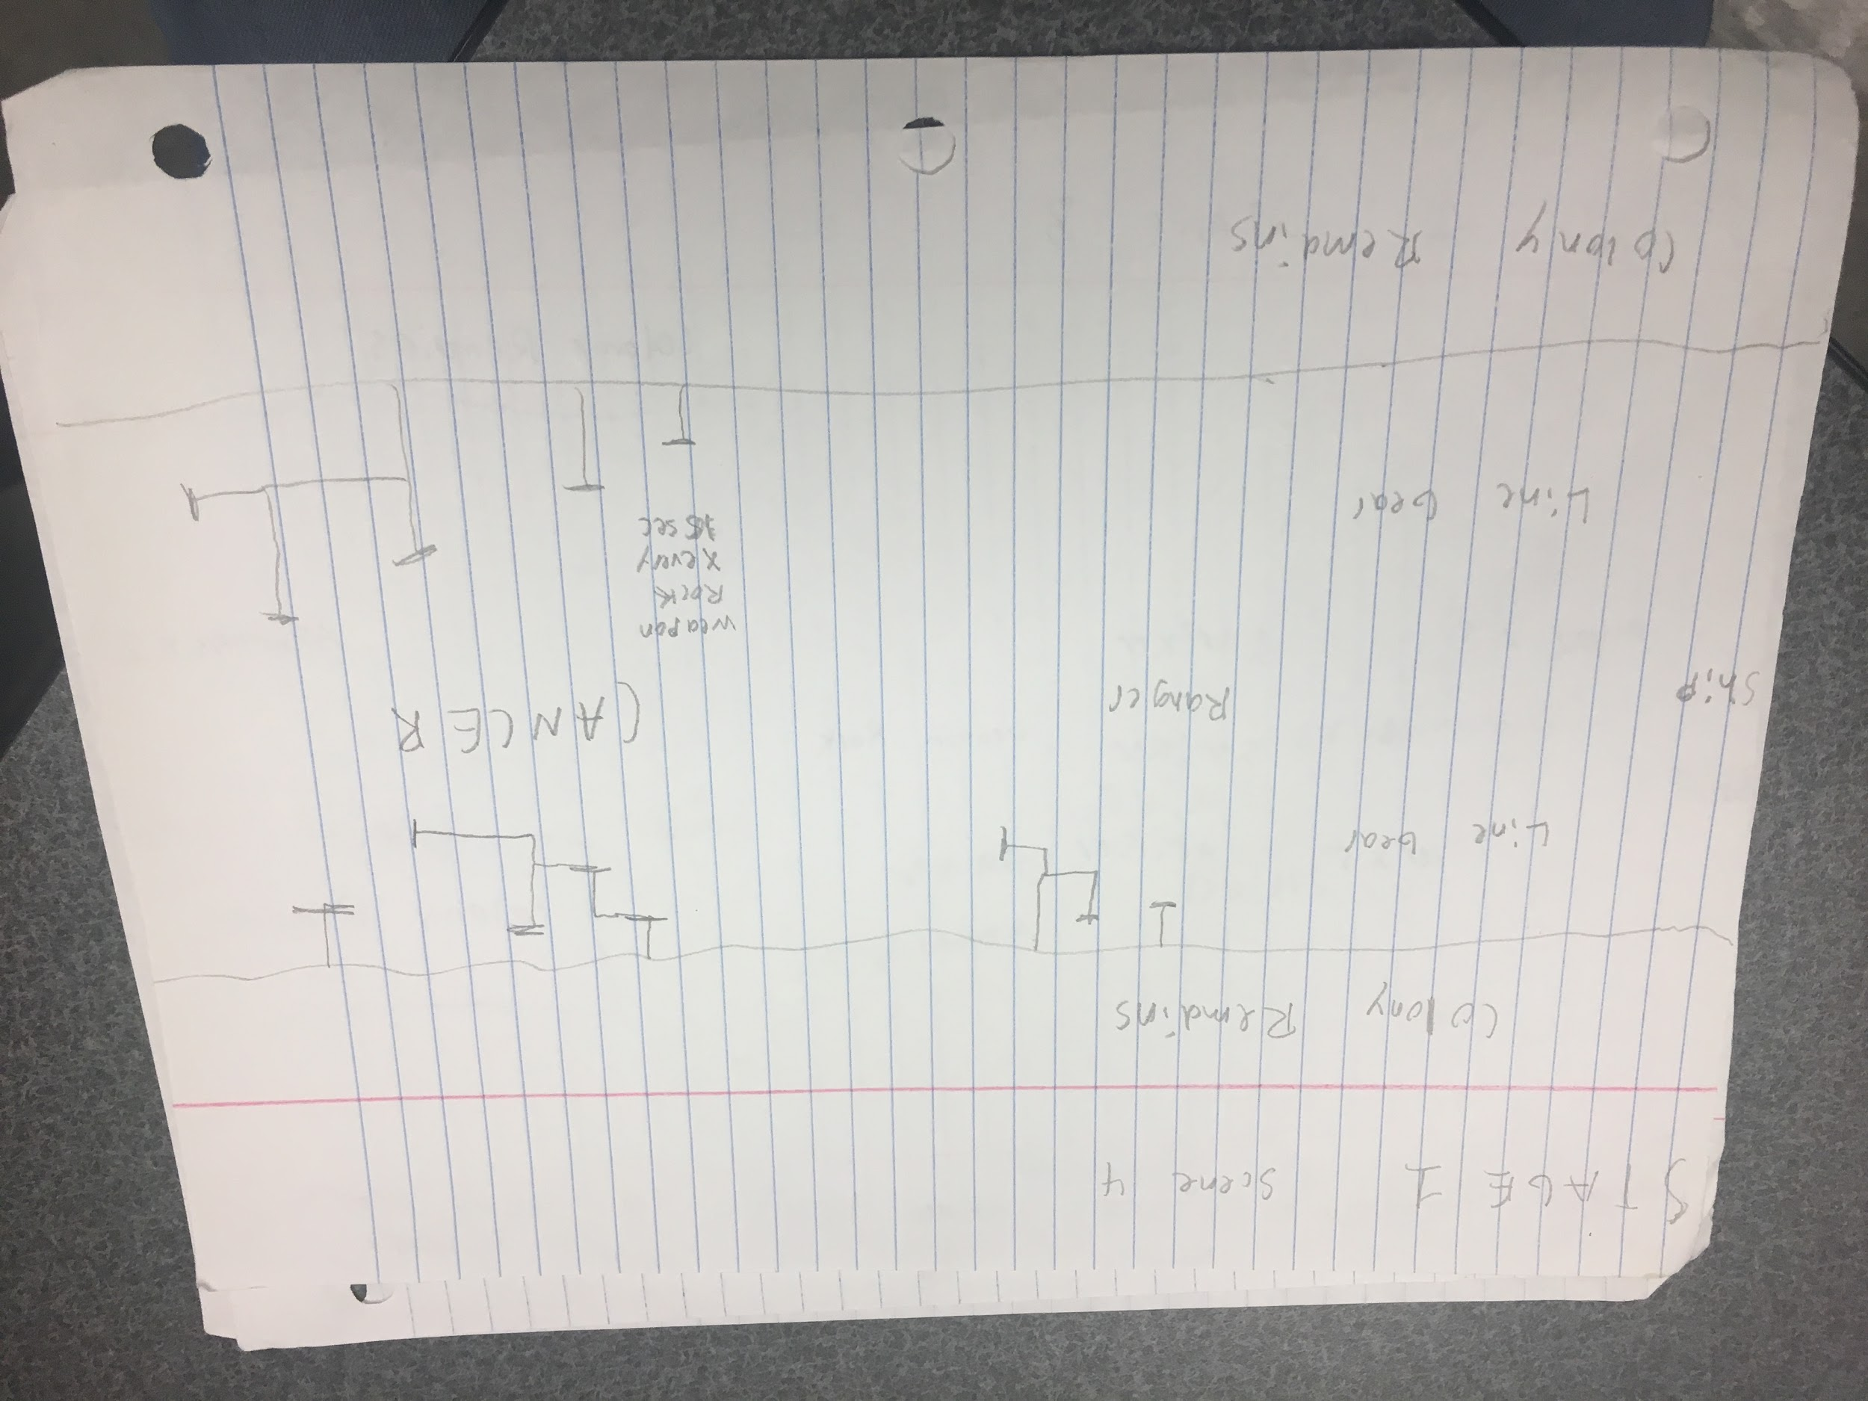

The above images show the level plan of the first stage. The “scene” is just what could fit on a page and does not reflect the level (it is continuous and only stops when the boss character is reached on the fourth “scene”). All positions of objects are listed but are relative (if something is higher than the other, it will be at a higher position but not necessarily that close to each other). Each object is listed by name (ship means player which can be anywhere but defaults to the back center for convenience on this mockup. Certain enemies should appear in waves and as a result the amount that should appear at once is listed as a number (if x3 is by name, that means 3 must spawn at that relative location and at a rate based on the enemy (so fast enemy will spawn in fast succession, medium at medium, etc.)).

The included objects in the game include: Flyer, Assaulter, Striker, Ranger, Weapon Rock, Line Gear, Colony Remains, and boss CANCER.

The stage ends when CANCER is defeated. When the player reaches the boss (and all bosses), the stage stops moving and the player “fights” the boss. During this phase (and all bosses), all items/enemies will spawn at a rate listed( for example the weapon rock appears every 15 seconds on screen).

The setting/background of this stage is deep space, where eventually the character enters a chamber like area of colony wreckage where the fight against the boss occurs (like it was waiting for you).

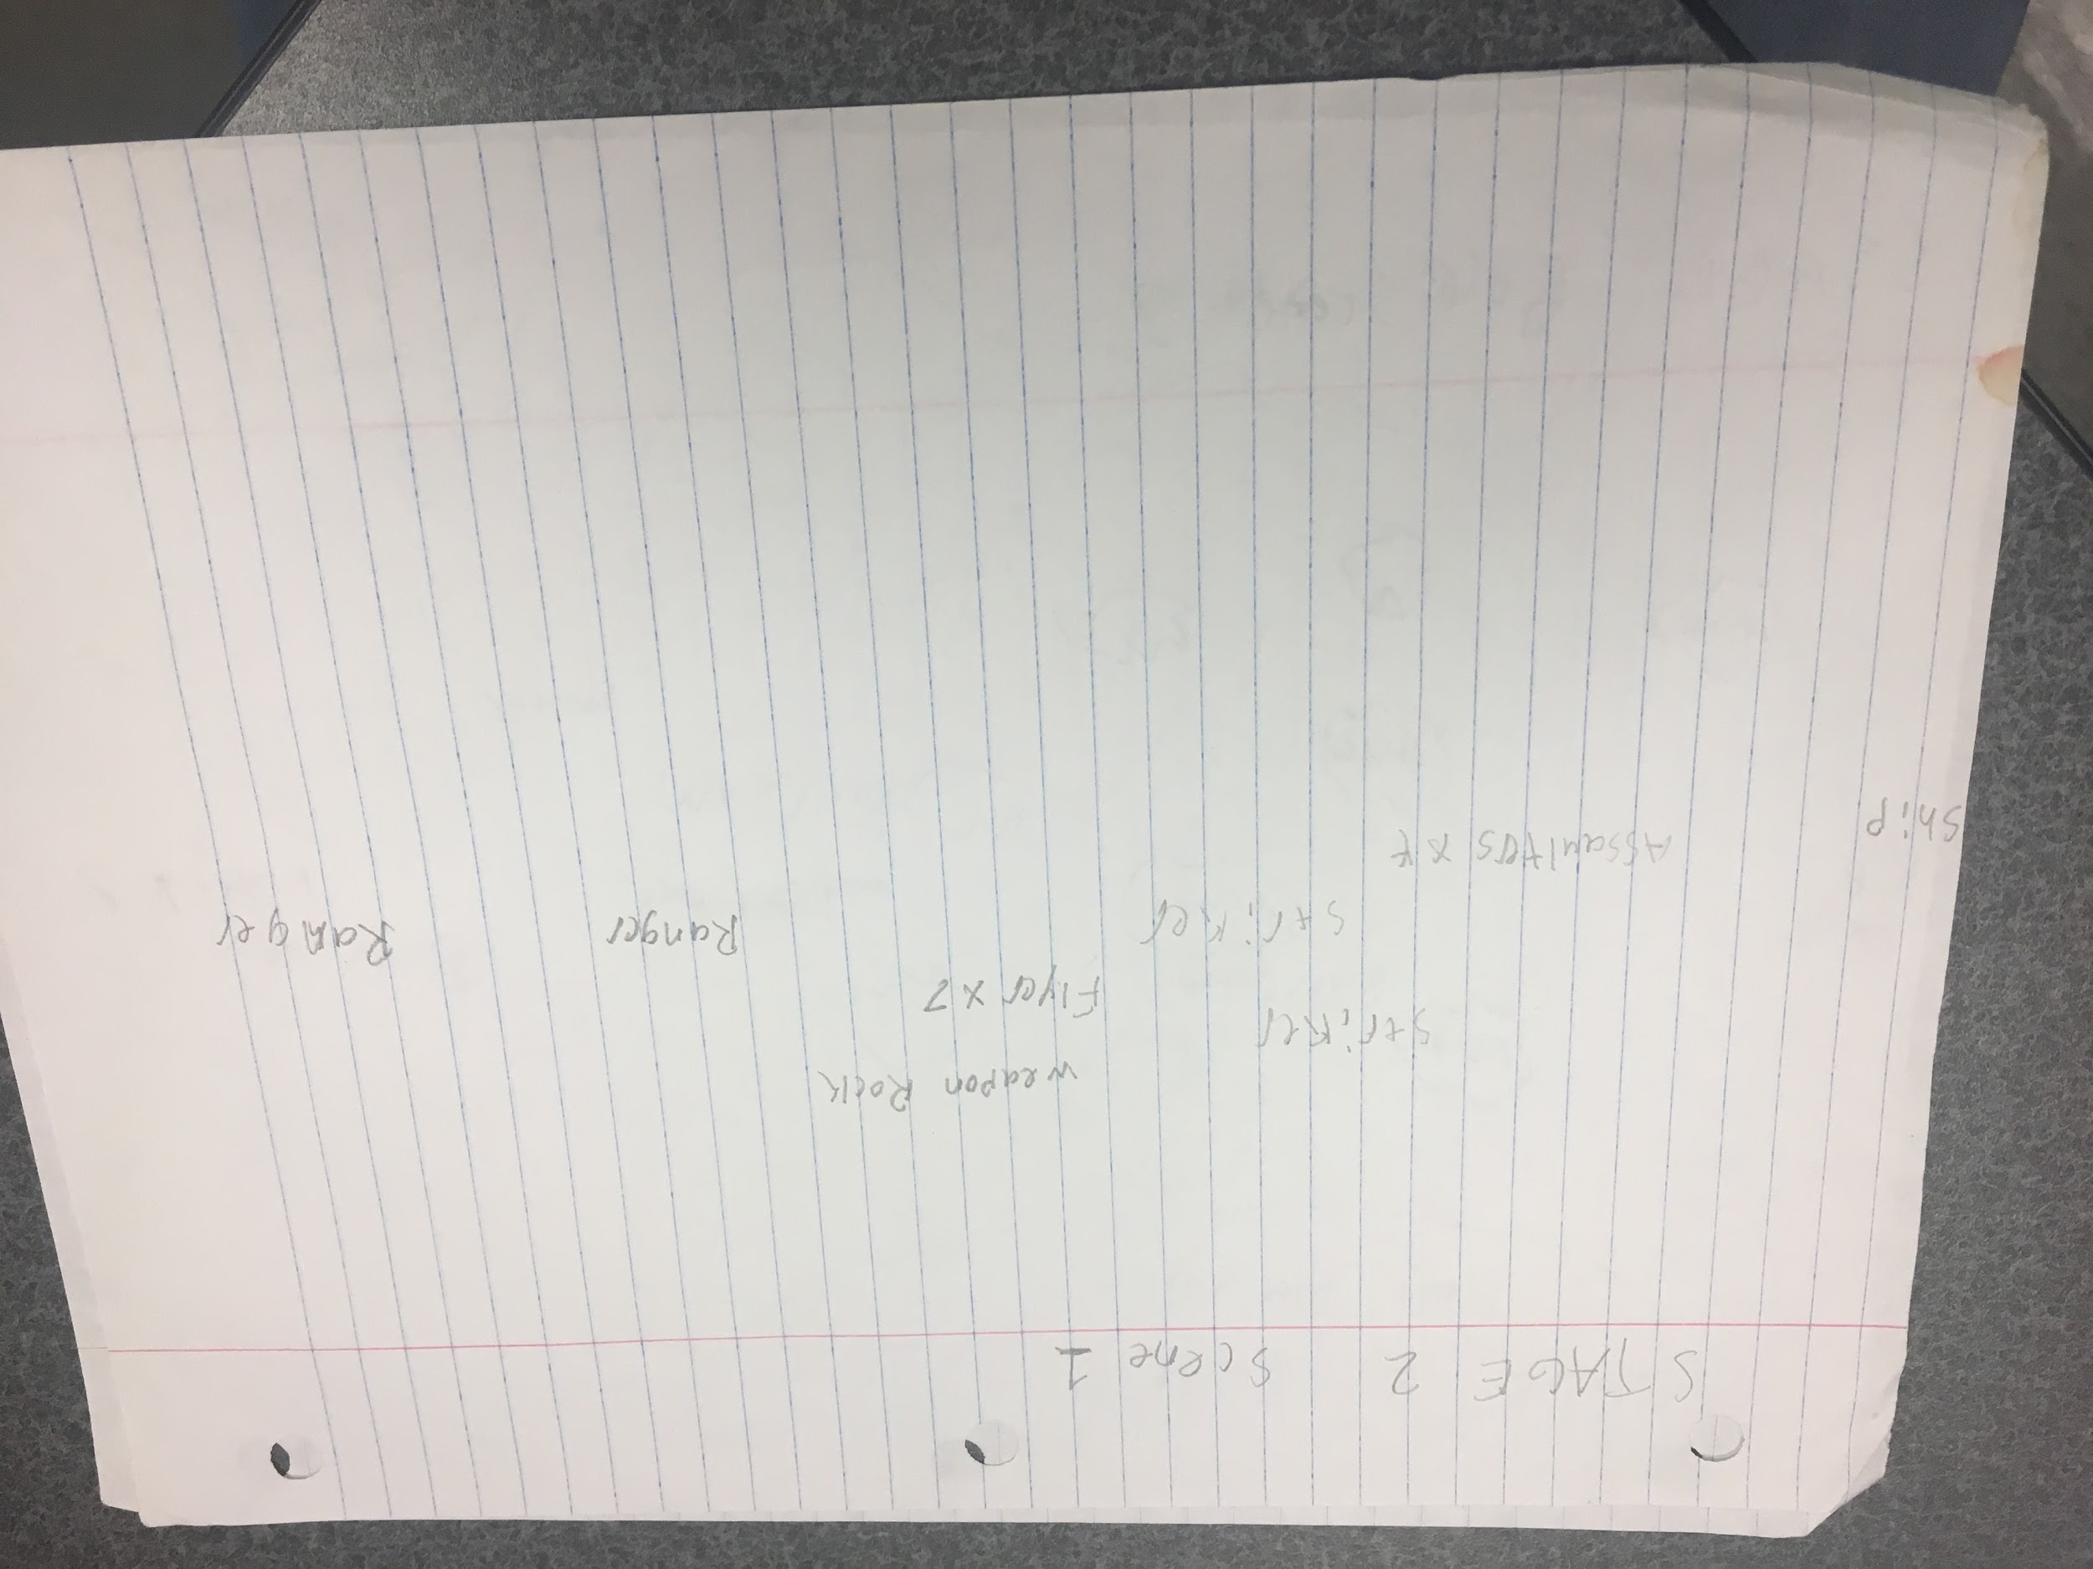

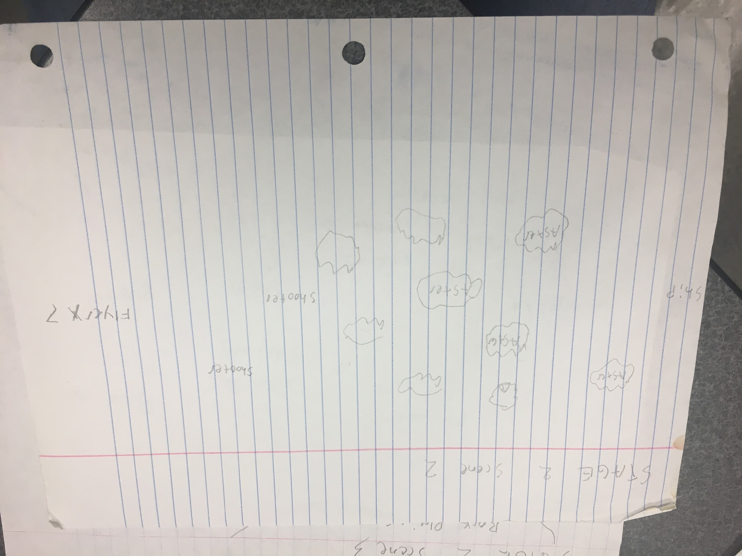

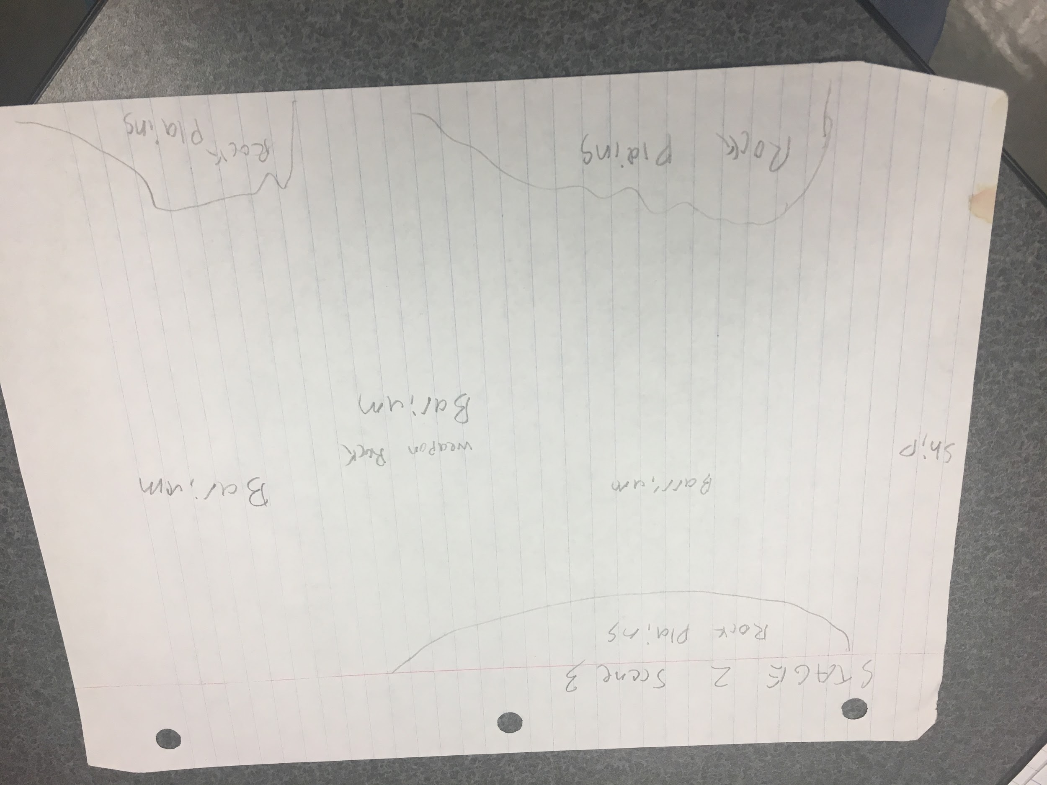

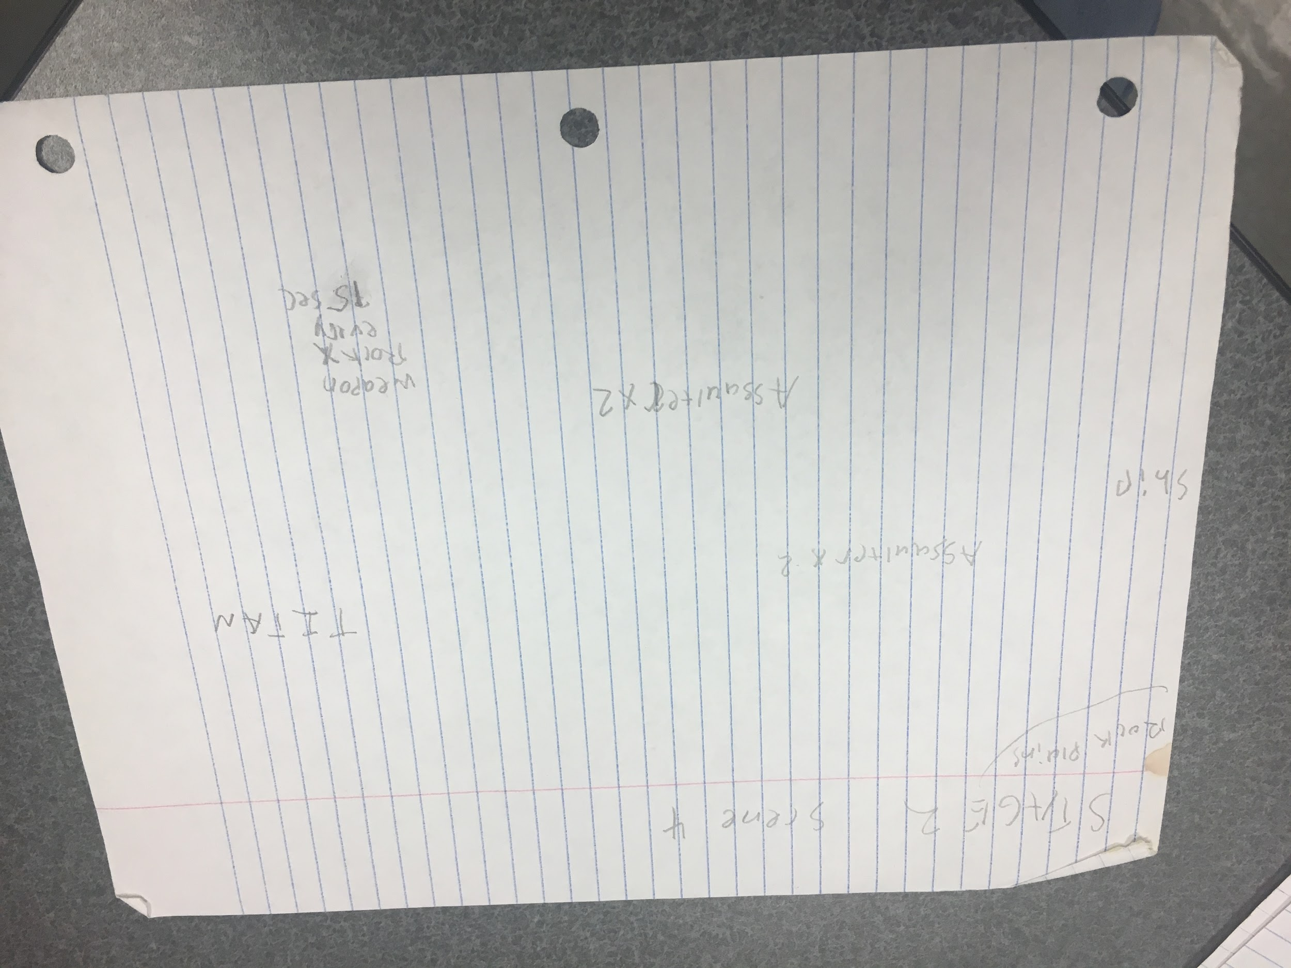

The above images are the plan of STAGE 2.

The included objects are: Assualters, Striker, Flyer, Weapon Rock, Ranger, Asteroids, Shooter, Rock Plains, Barrium, and TITAN.

The level is set in space where eventually the player runs into an asteroid filled (random asteroids to avoid). Then rock plains will be on the outskirts of the level, until they finally clear as you approach the boss.

TITAN should fire its head projectile every 2 seconds, its foot missile every 4 seconds, and its main cannon every 6 seconds.

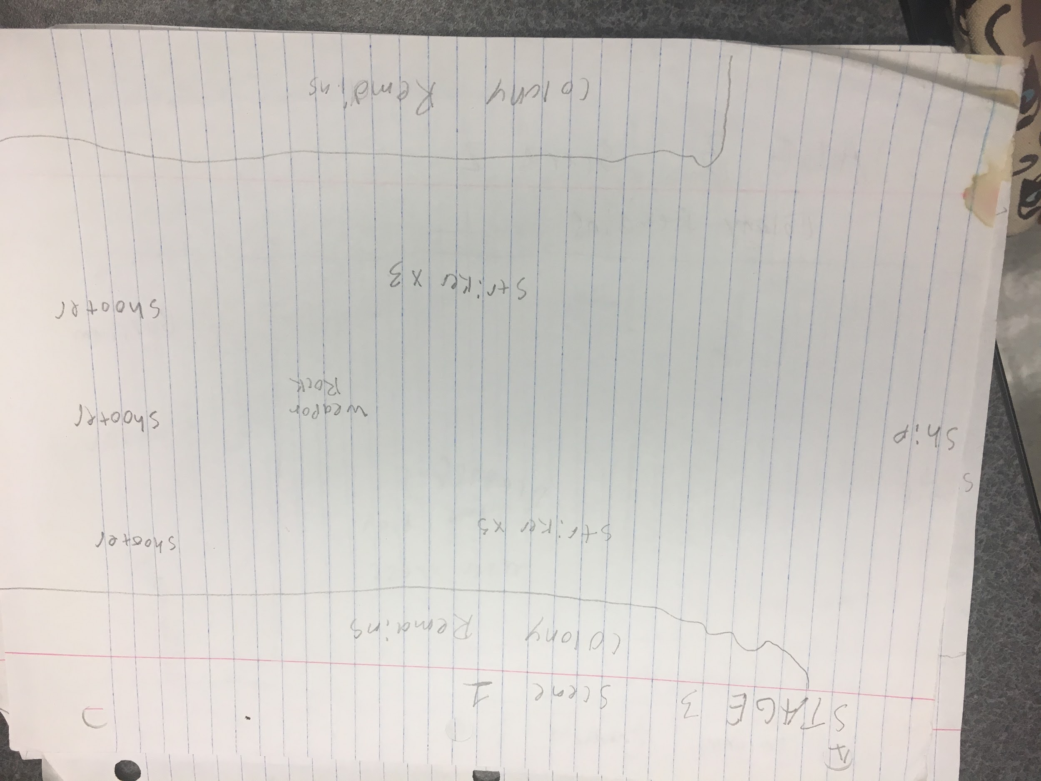

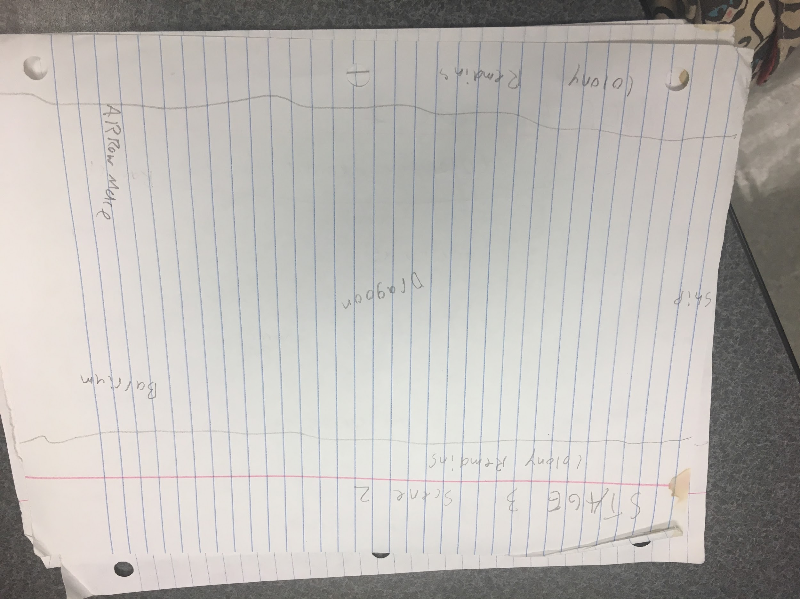

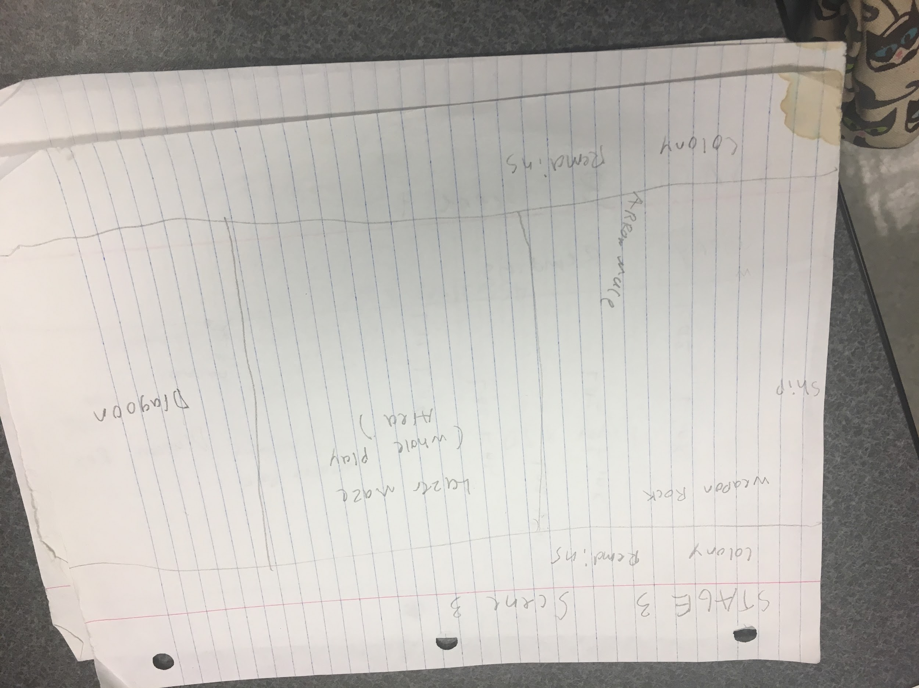

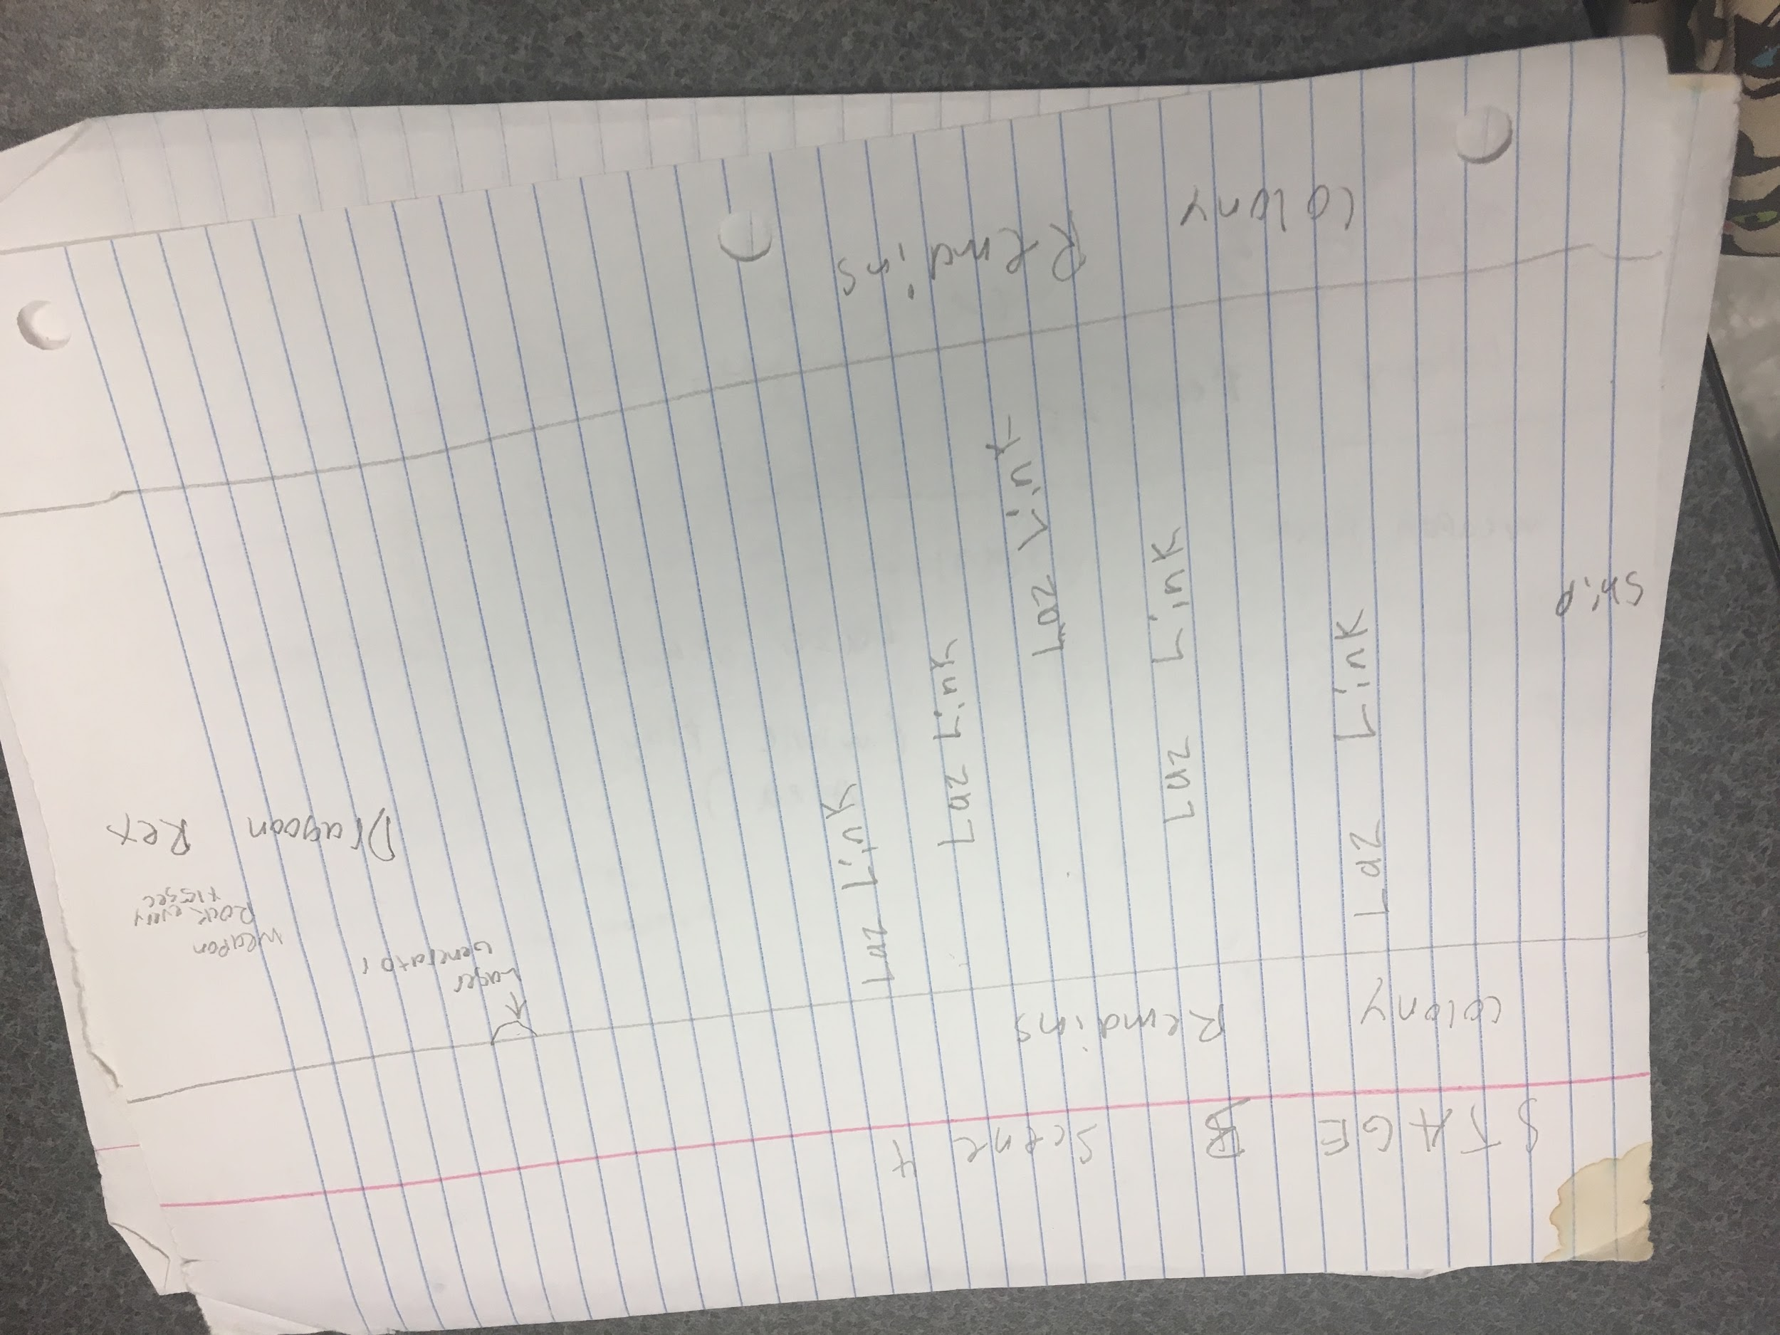

The above images is the layout of the third stage. The included obstacles are Striker, Shooter, Colony Remains, Weapon Rock, Dragoon, Barrium, Arrow Mace, Lazer Maze, Laz Link, and Dragoon Rex (with its lazer generator).

The scene takes place in a colony like base for the Xeon, so it should have colony boundaries throughout with a metallic-base like background (like machinery etc.)

When reached Dragoon Rex, it should shift postions every 8 secs. Missiles should fire every 2 secs when able, the nose should shot its flame once per cycle, the laser generator should fire every 6 secs and last for 2 secs. When defeated, all weapons cease and the level ends.

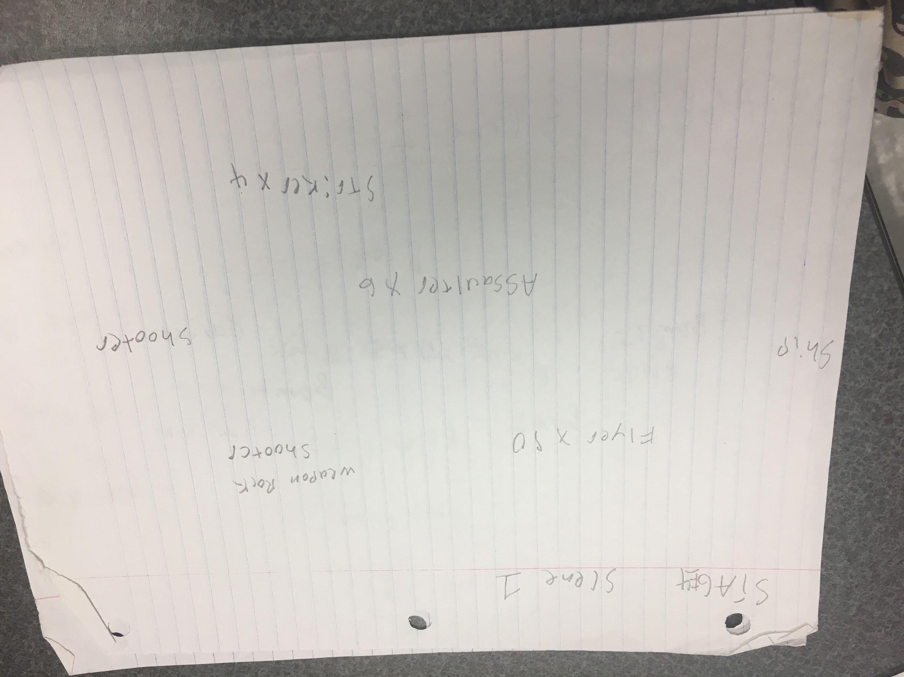

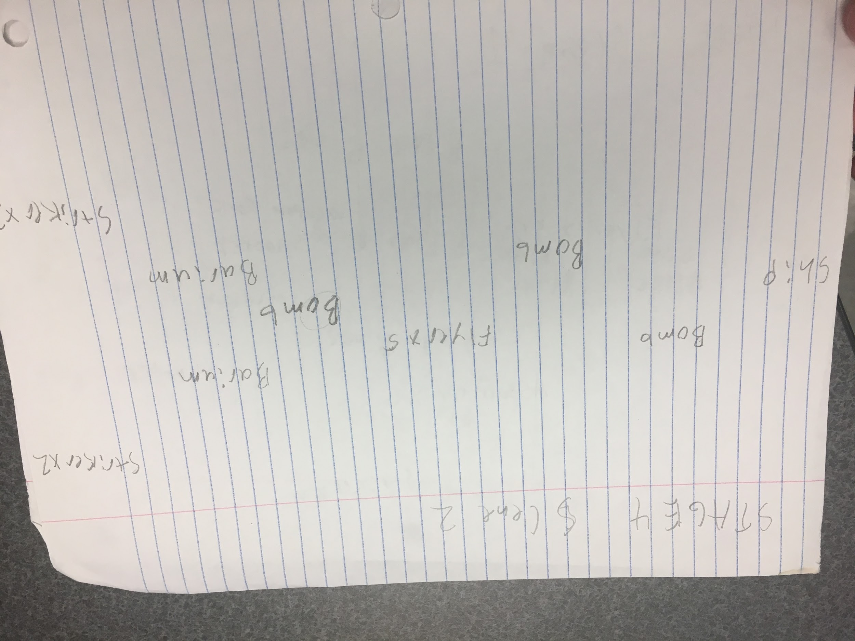

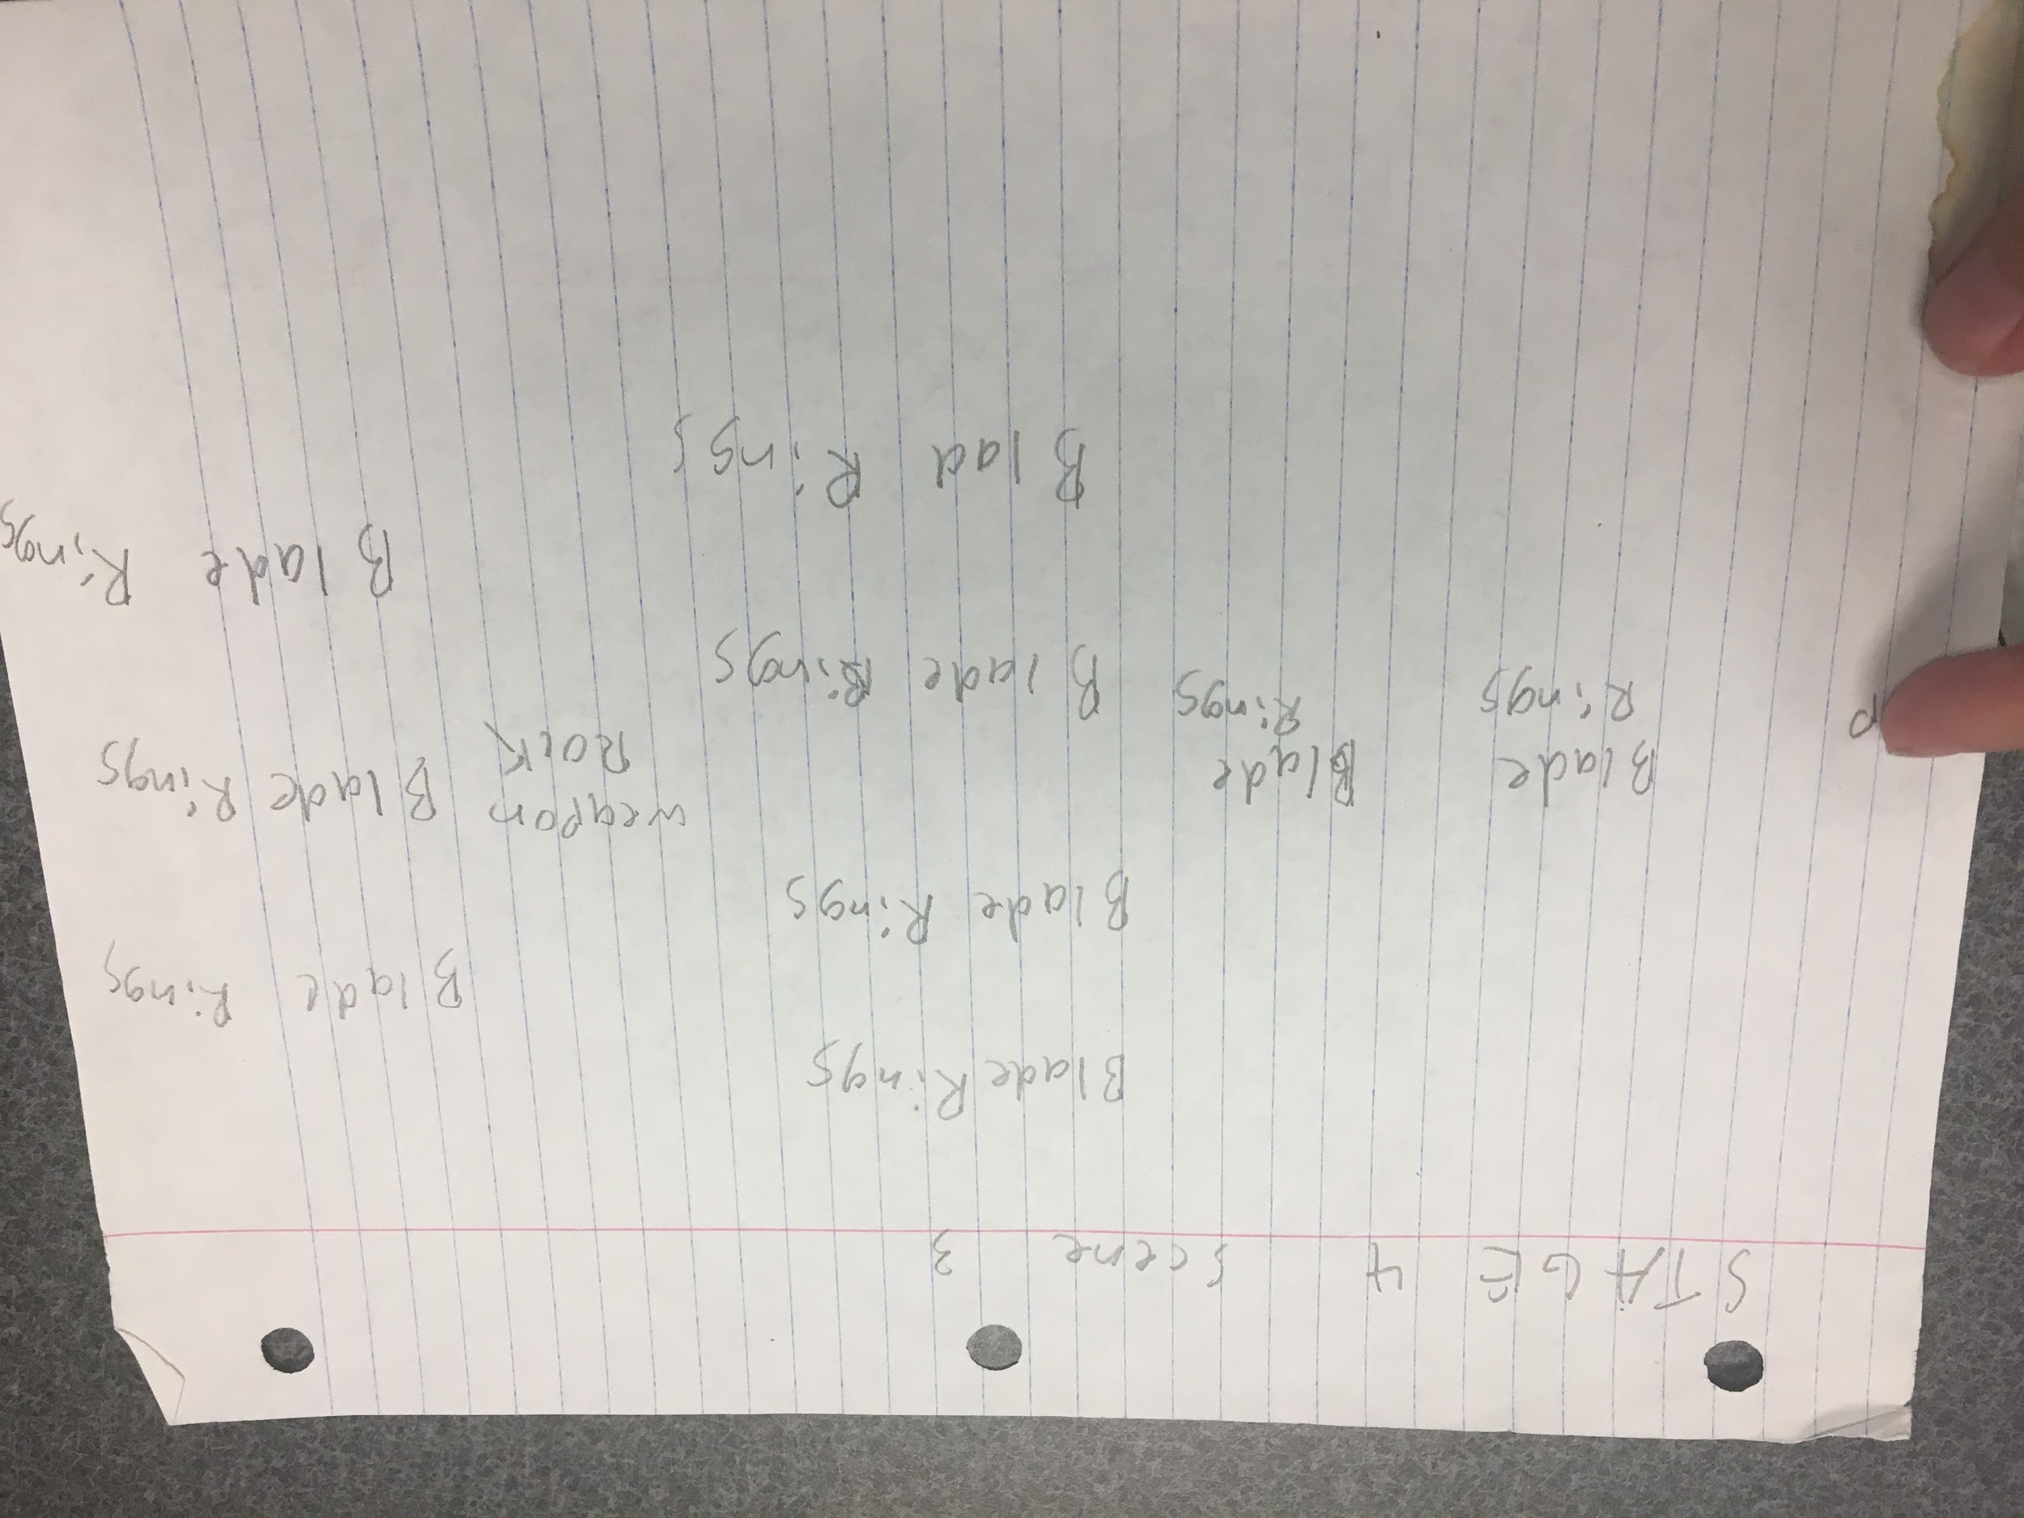

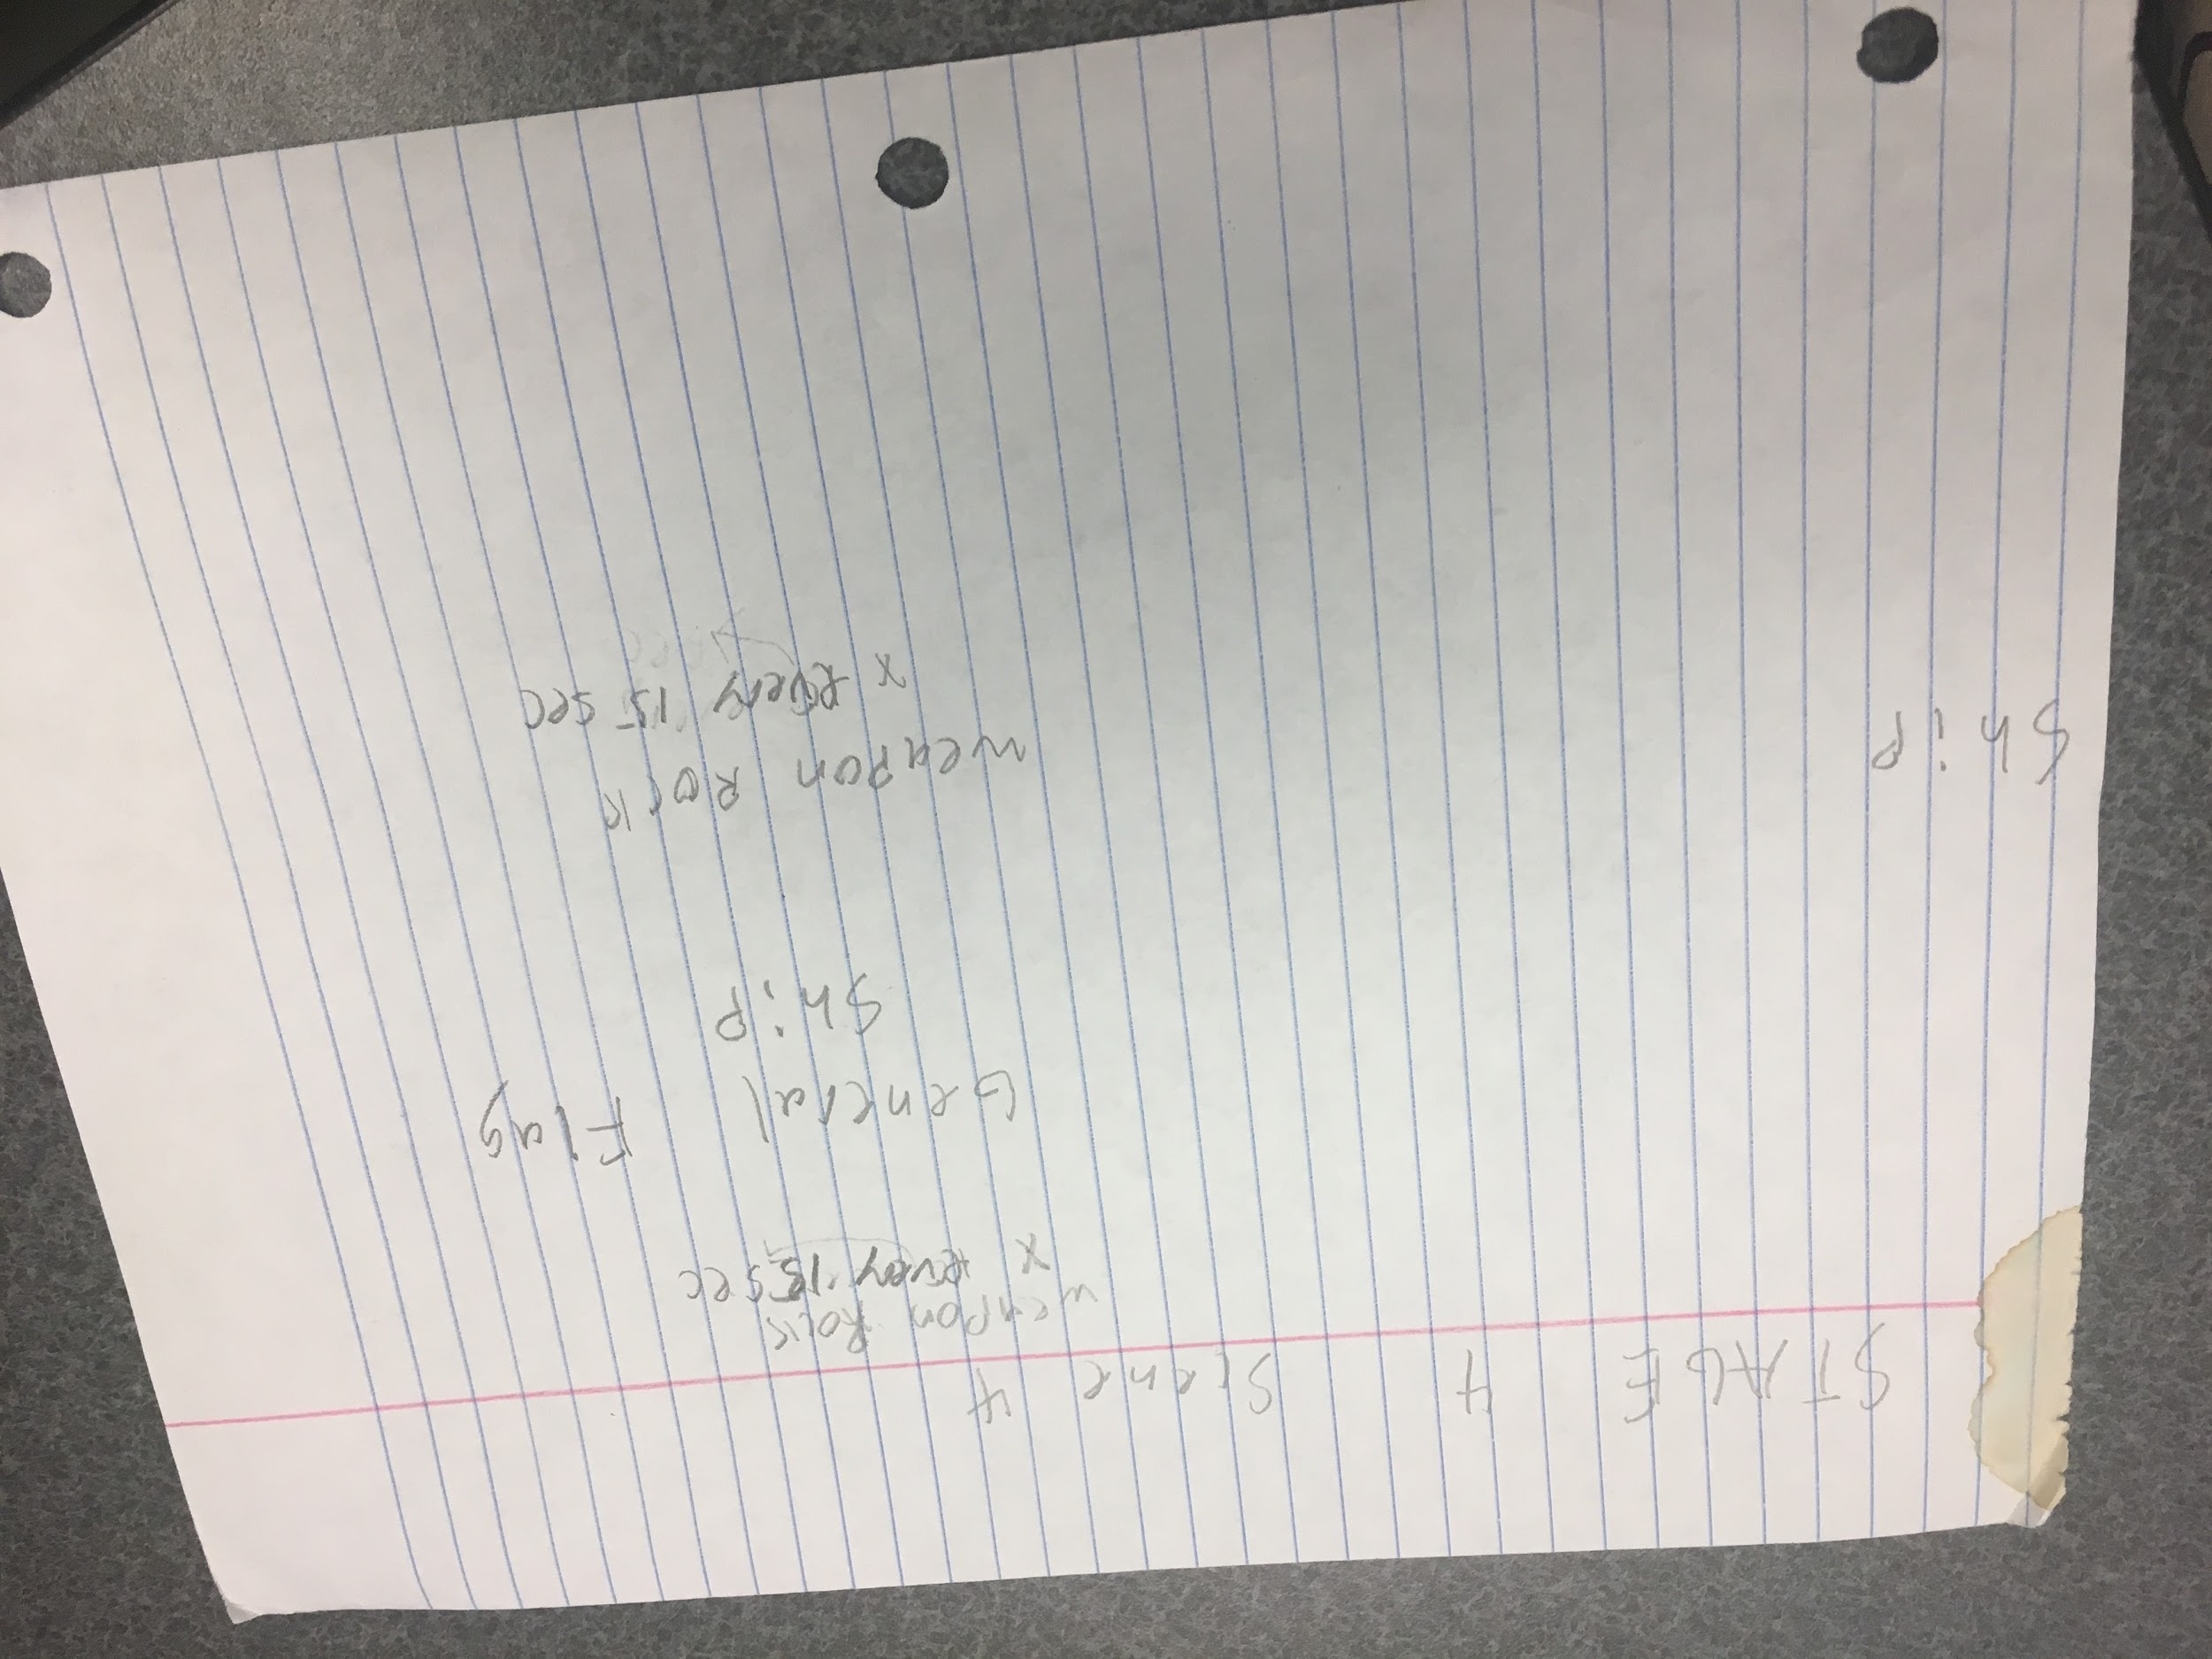

Above is the 4th and final stage in the game. The objects included are: Flyer, Shooter, Striker, Assaulter, Weapon Rock, Bomb, Barrium, Blade Rings, and General Flag Ship.

The scene is in space as the player reaches the general's ship (a grand finally battle).

During the battle, the flagship will launch projectiles every second from all standard cannons. It will fire its laser from wither cannon every 6 seconds. The enemy spawn will spawn every 2 seconds for flyer, 4 seconds for striker, and 6 seconds for barrium. Two weapon rocks spawn every 15 secs, one above the ship and the other below the ship, inbetween the two wing sections. When all four sections have been depleted of their “health”, the ship blow up and the stage is completed, and goes to the victory screen.

Then the player’s username is linked to their score and presented if they reached top ten status (also will be shown if they ever run out of tries).

# Art design

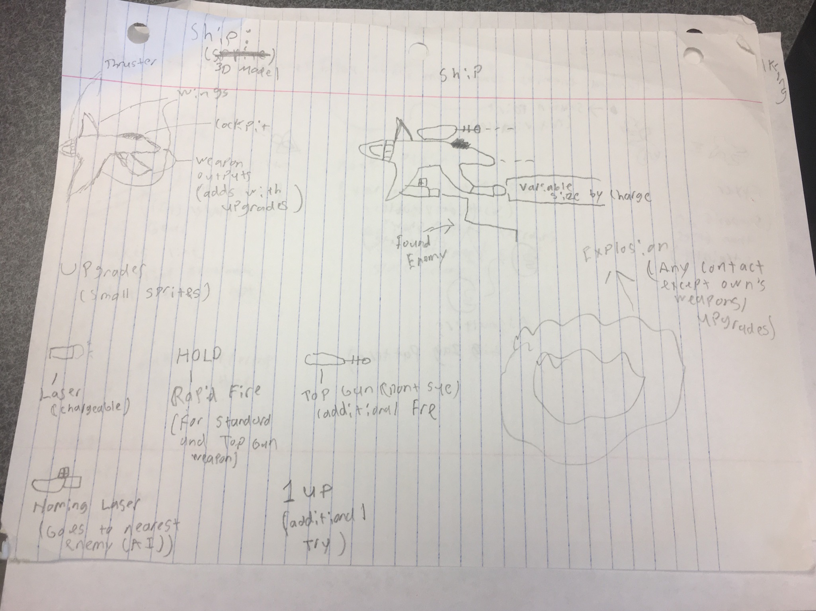

The above image is rough design of the player ship (SF-13) with various upgrades, and how they look. The ship on the left is the default ship at the start of a try. The 3 weapon type upgrades add visually to the player model when obtained. An explosion model will occur when the ship is contacted by enemy/ or other projectile. The ship colors should look heroic (white main color with some blue and red highlights). The upgrades should match the theme of the ship as well.

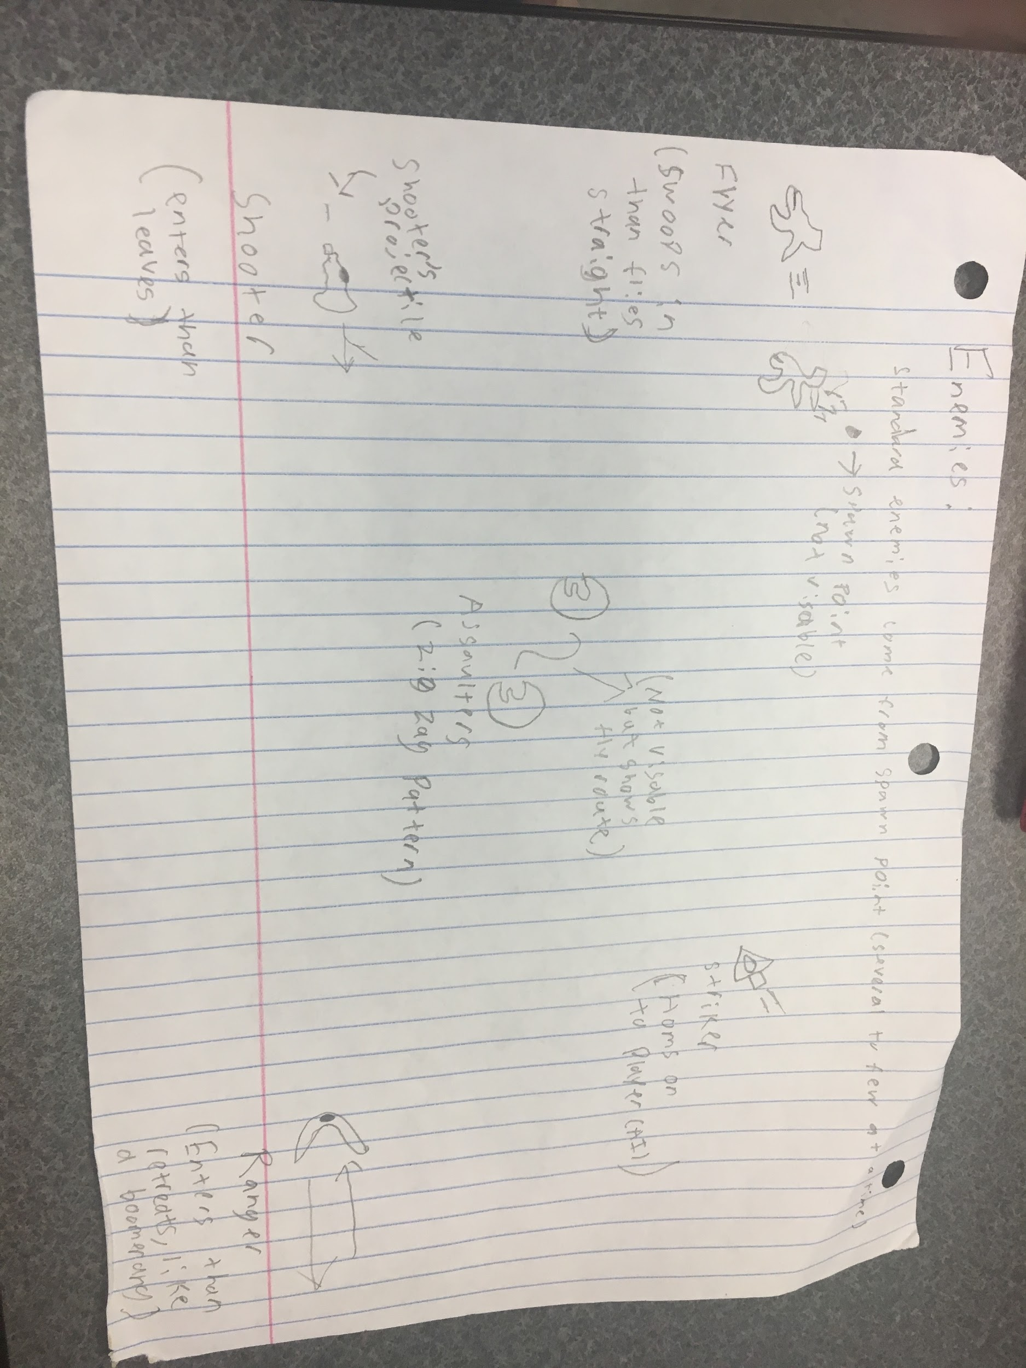

The above image contains mock ups of 5 of the enemies (listed in picture). Flyer should look like a parody of the player ship but obviously not (small and different color, like purple). Assaulter should be a try wing shape/moon shape with a light green color. Striker resembles an arrow which alludes to its behavior (make it a yellow color).

Shooter should be like a little turret like gun with a little nozzle where the projectile comes out (make it a light blue). The projectile must be different in color than the player’s projectile (make enemiesRanger is like a boomerang, in shape and in behavior, though it should only be facing where it is going not rotate (left when going left, then right when retreating). Also a dark orange color would match the enemy.

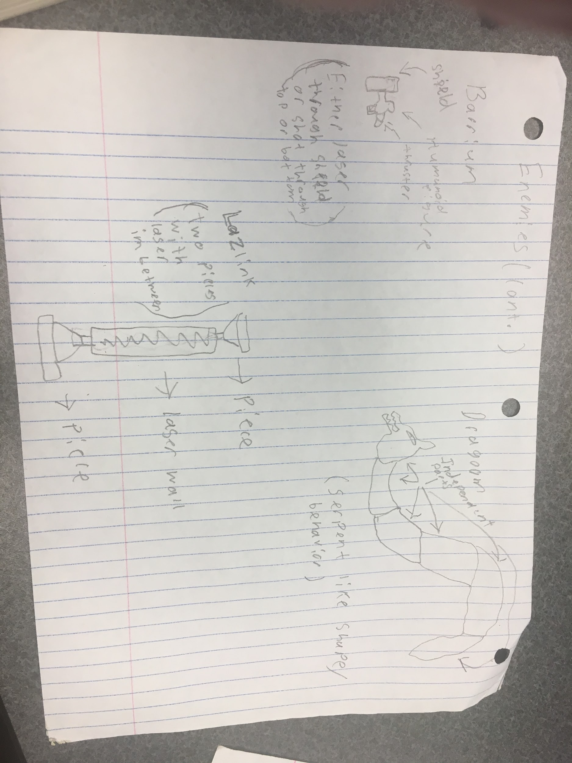

The above image showcases the remaining standard enemies. Barrium resembles a mini human robot with a shield object in front which protect them from harm of standard shots (hell be a light grey/white color). Dragoon is a serpent like dragon that moves around the screen like a snake. Each section should be a destroyable and follow the same path even if broken up (they all should be a red color). Lastly is the lazlink which is to funnel shaped machines that emit a laser in between that is only destroyed when one of the machines is destroyed. The machines will have a silver color with gold highlights and the laser will be a light blue.

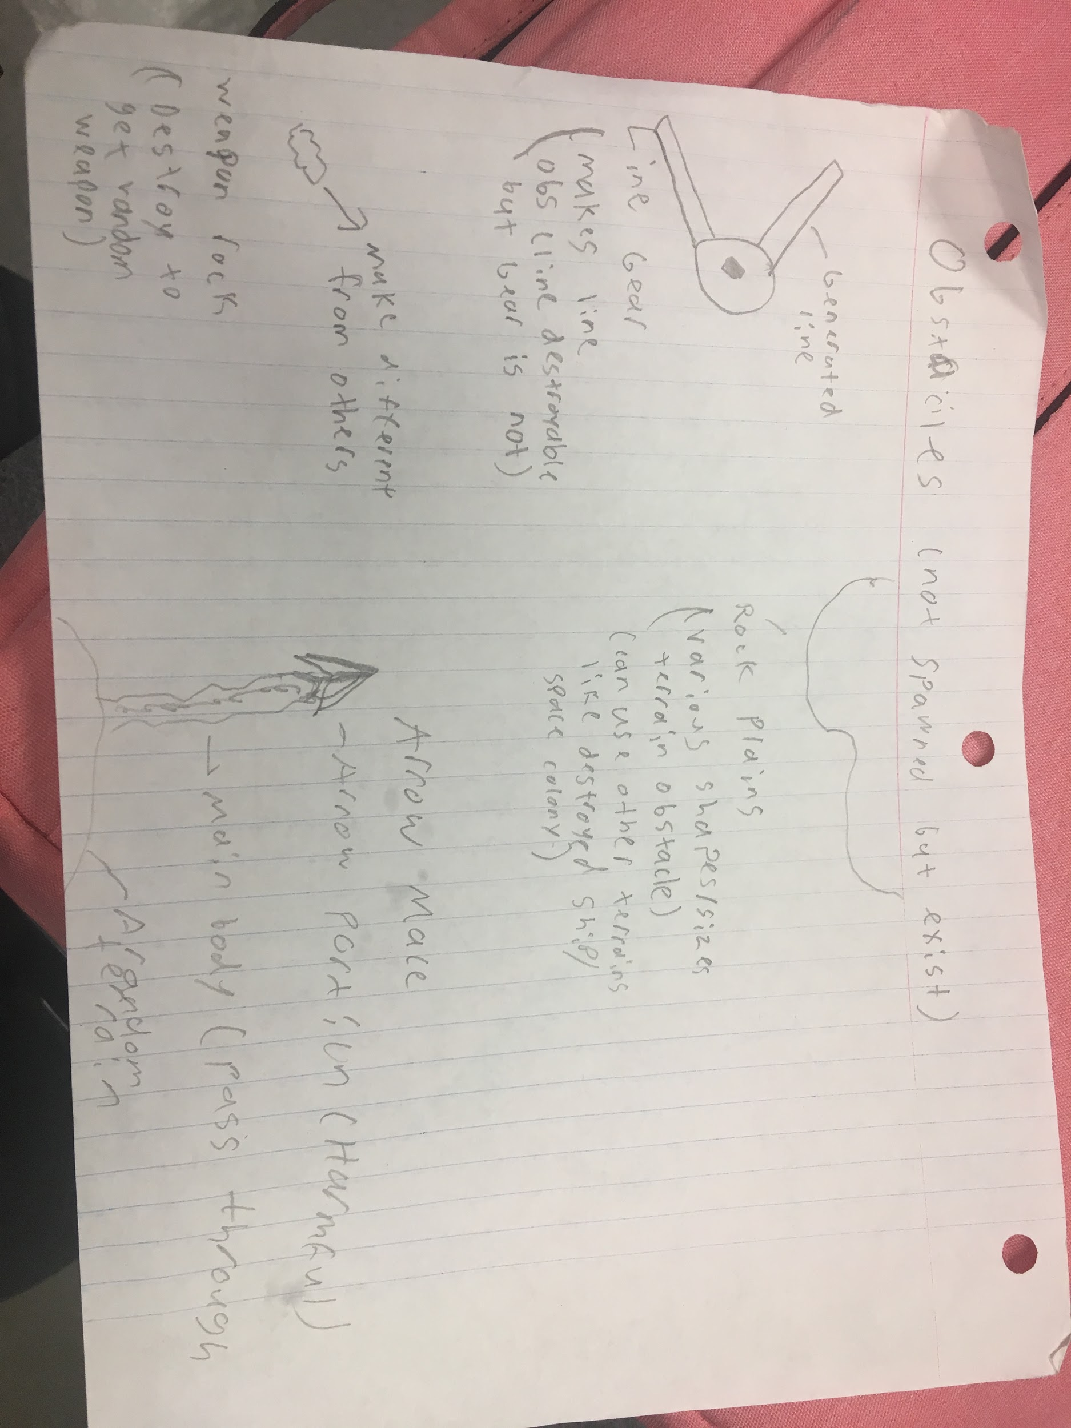

The above image contains obstacles that occur in the game. Line Gear is a circular object that generates line from itself to block the player. It will be grey with blue highlights. Rock plains are random shapes of rocks that appear in levels (brown is typical color). Weapon rock is where the player finds upgrades. The rock will be brown but flash yellow, indicating it is not a normal rock. The Arrow Mace is a spear like in shape that flails around, attached to a terrain. A black and red highlight colors would fit.

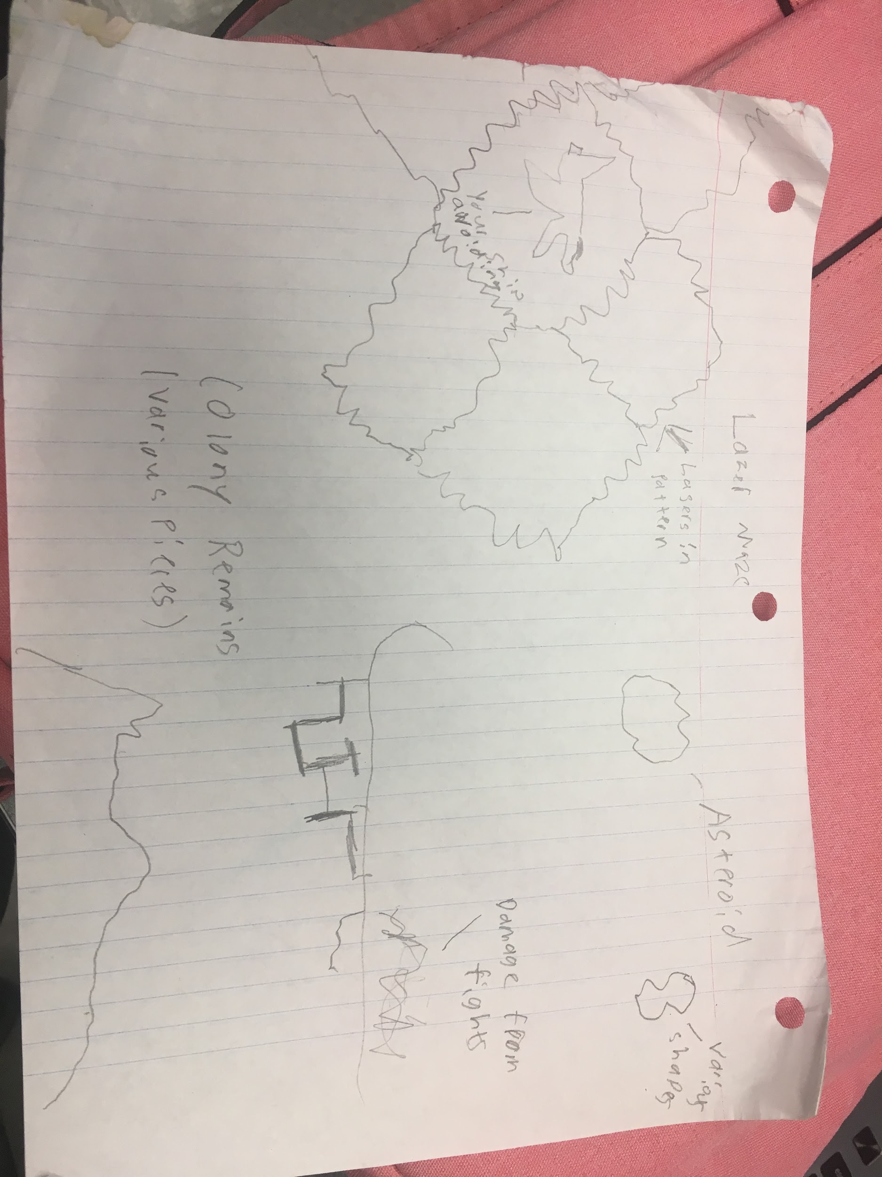

Above is more obstacles. The lazer maze is a grid like pattern of lasers that appear in time intervals. A yellow laser color is desired. Colony remains are metallic shapes of former colonies. They will be grey with darker grey frames exposed on some remains (the darker portion of the middle image). Asteroids are rocks that move across the screen. Various sizes, shapes (should also be brown).

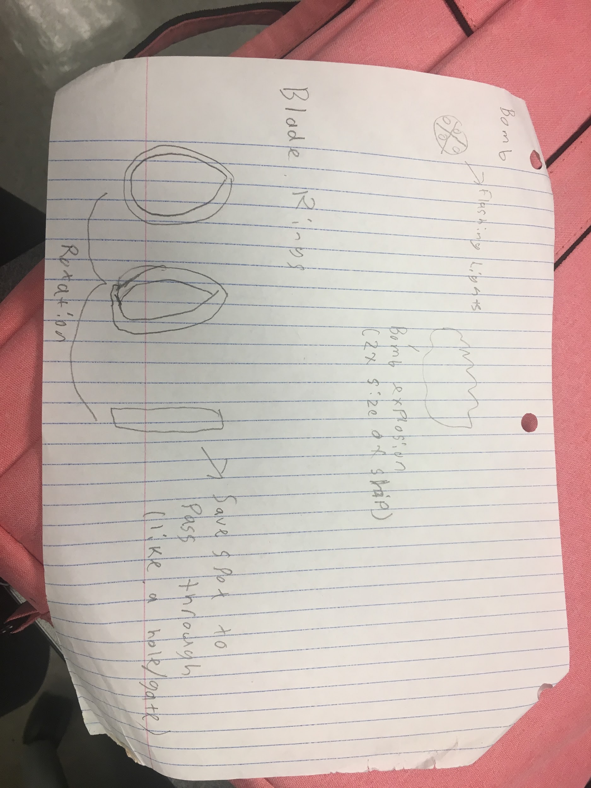

Above is the remaining list of obstacles in the game. The bomb will be a spherical object with a cross pattern. When touched or shot by player, it will explode and have an explosion radius of 2 times the SF-13. The bomb will be a dark purple (nearly black) with red lights (not flashing) and explosion a standard orange/red color. Blade rings are green laser rings that rotate on screen (as shown).

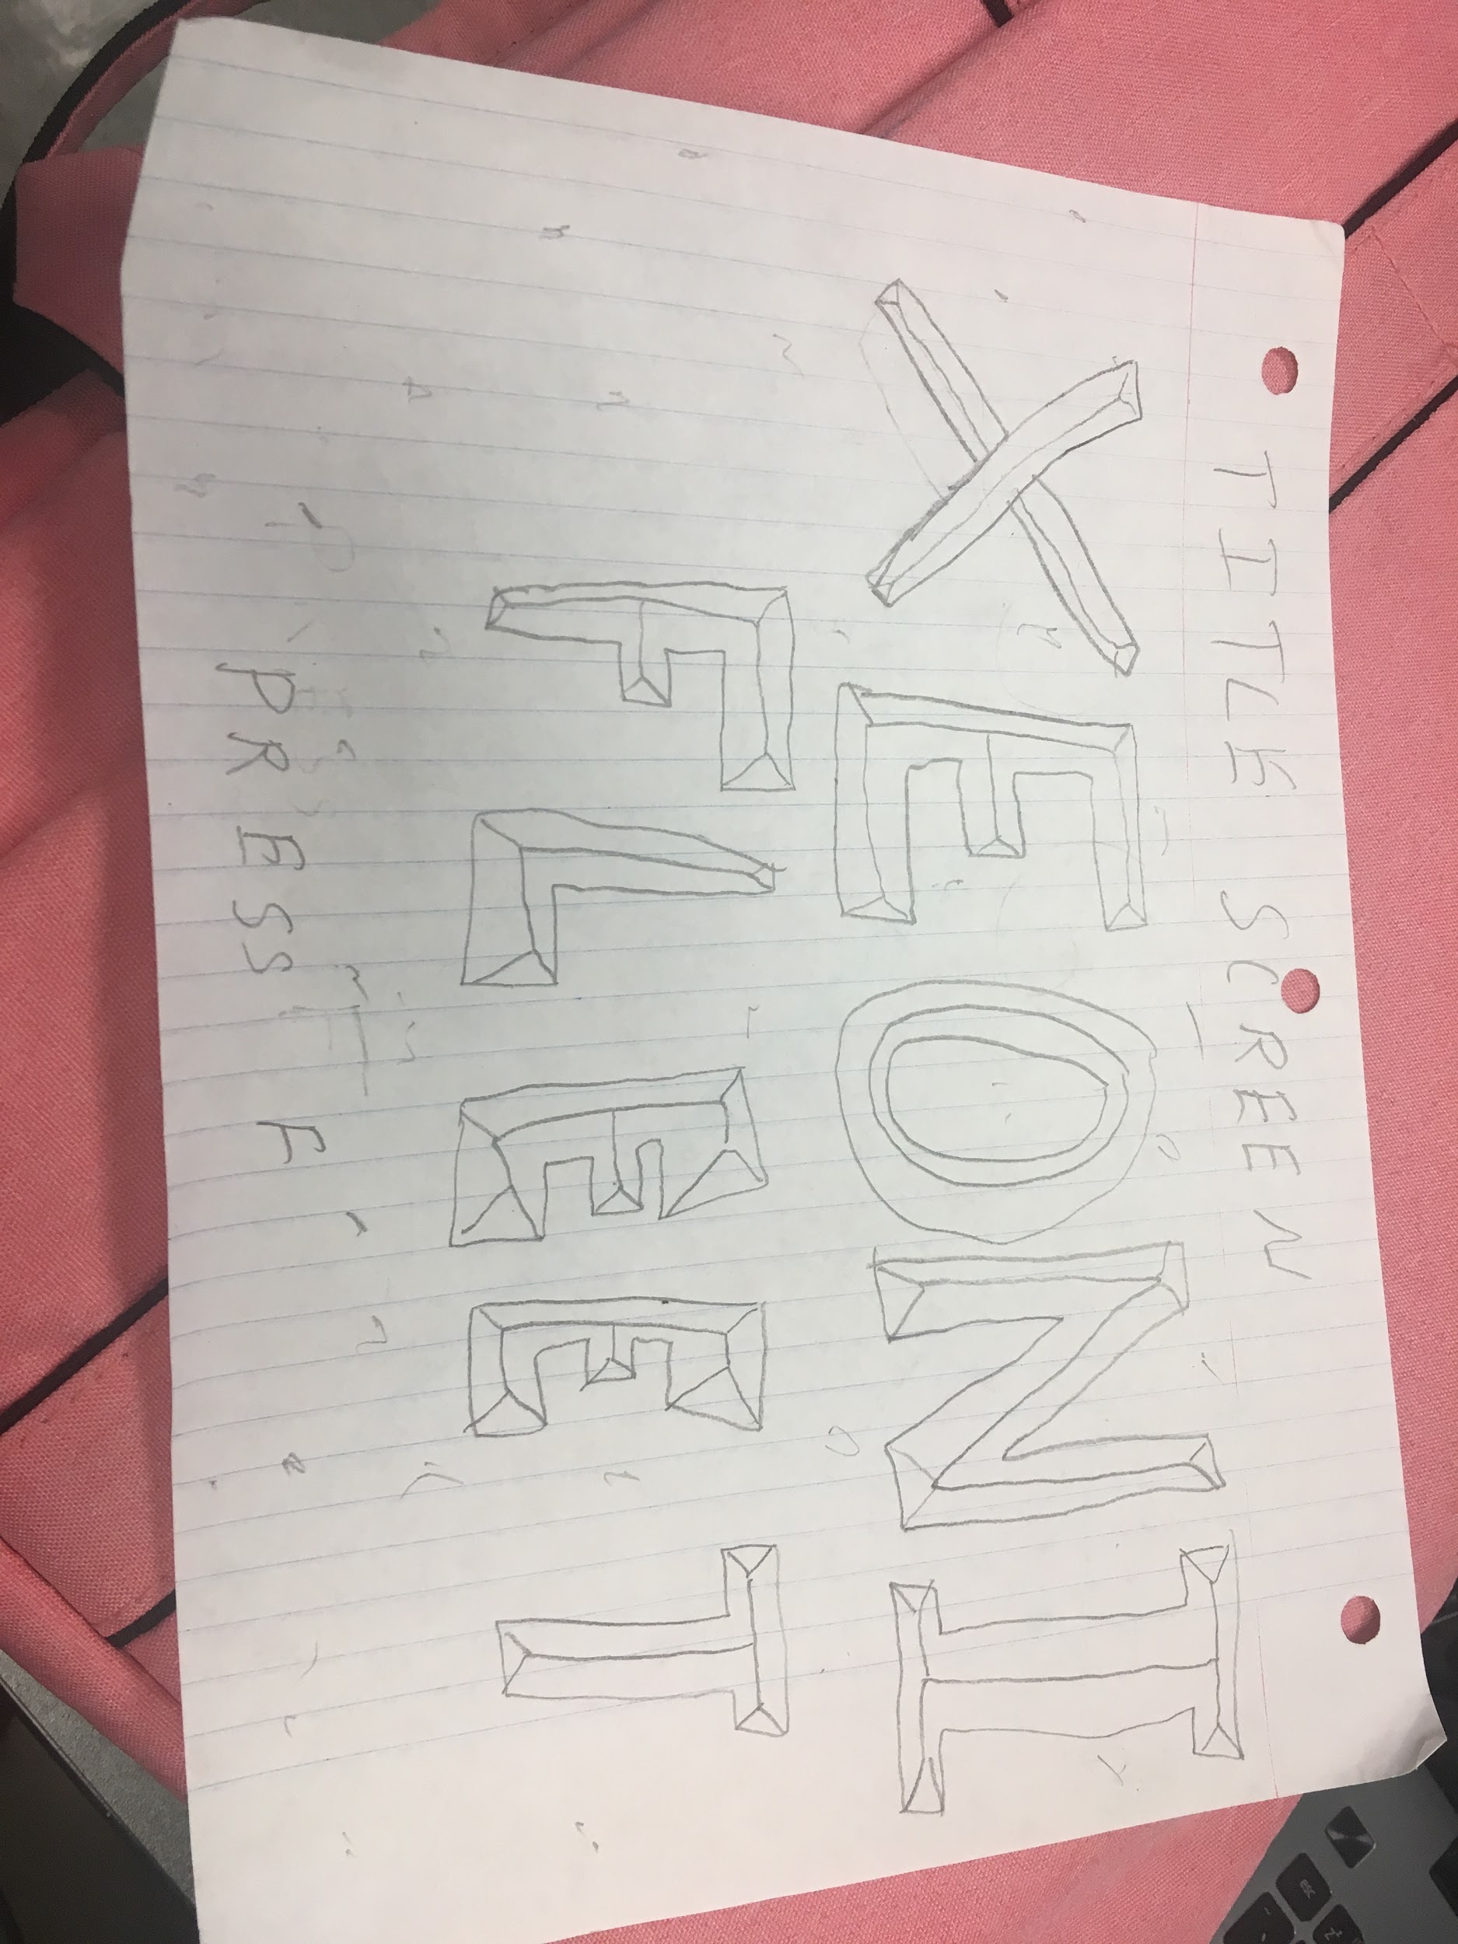

The above is the prototype of the game start screen. It will have Xeonic Fleets logo in the center with prompt to press f to start game. In the background will the stars in space. The logo is not set in stone but will be a blue/red color like the player’s ship. It also be staggered, like in the picture.

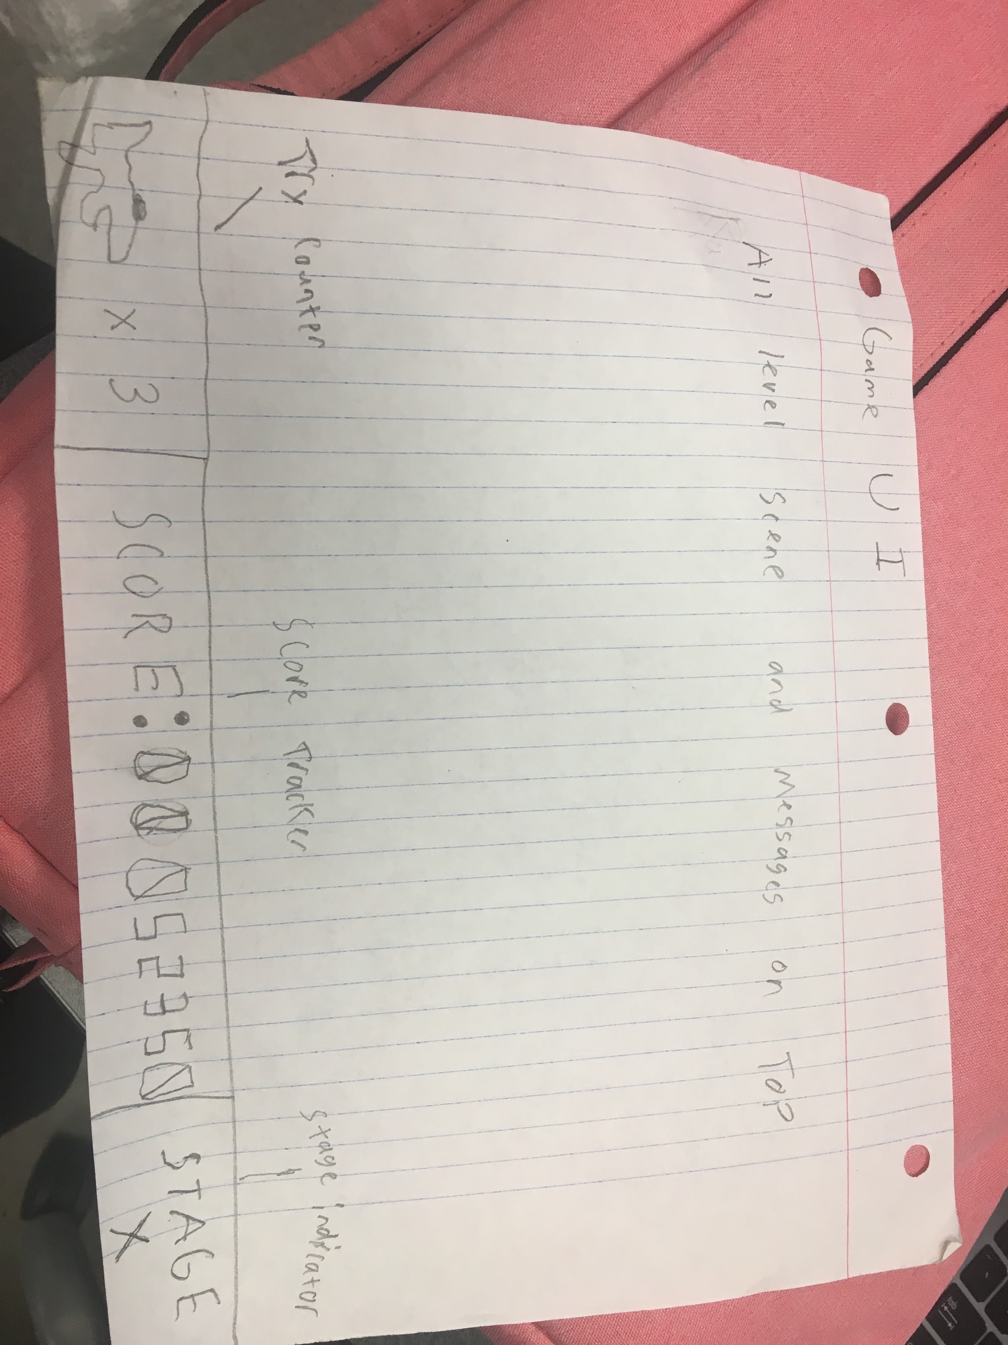

The above is the ui of the game. The play screen will be the top portion of the screen. The bottom row has 3 segments. The left is the list of tries, it has a mini image of the shipe with the amount of tries remaining (when it reaches zero, the game is over. There is no limit to how many tries one can get). The center will be score, it is all zeros and when the player obtains score, it will change. The right is the current stage, with Stage on top and the number of the stage on the bottom.

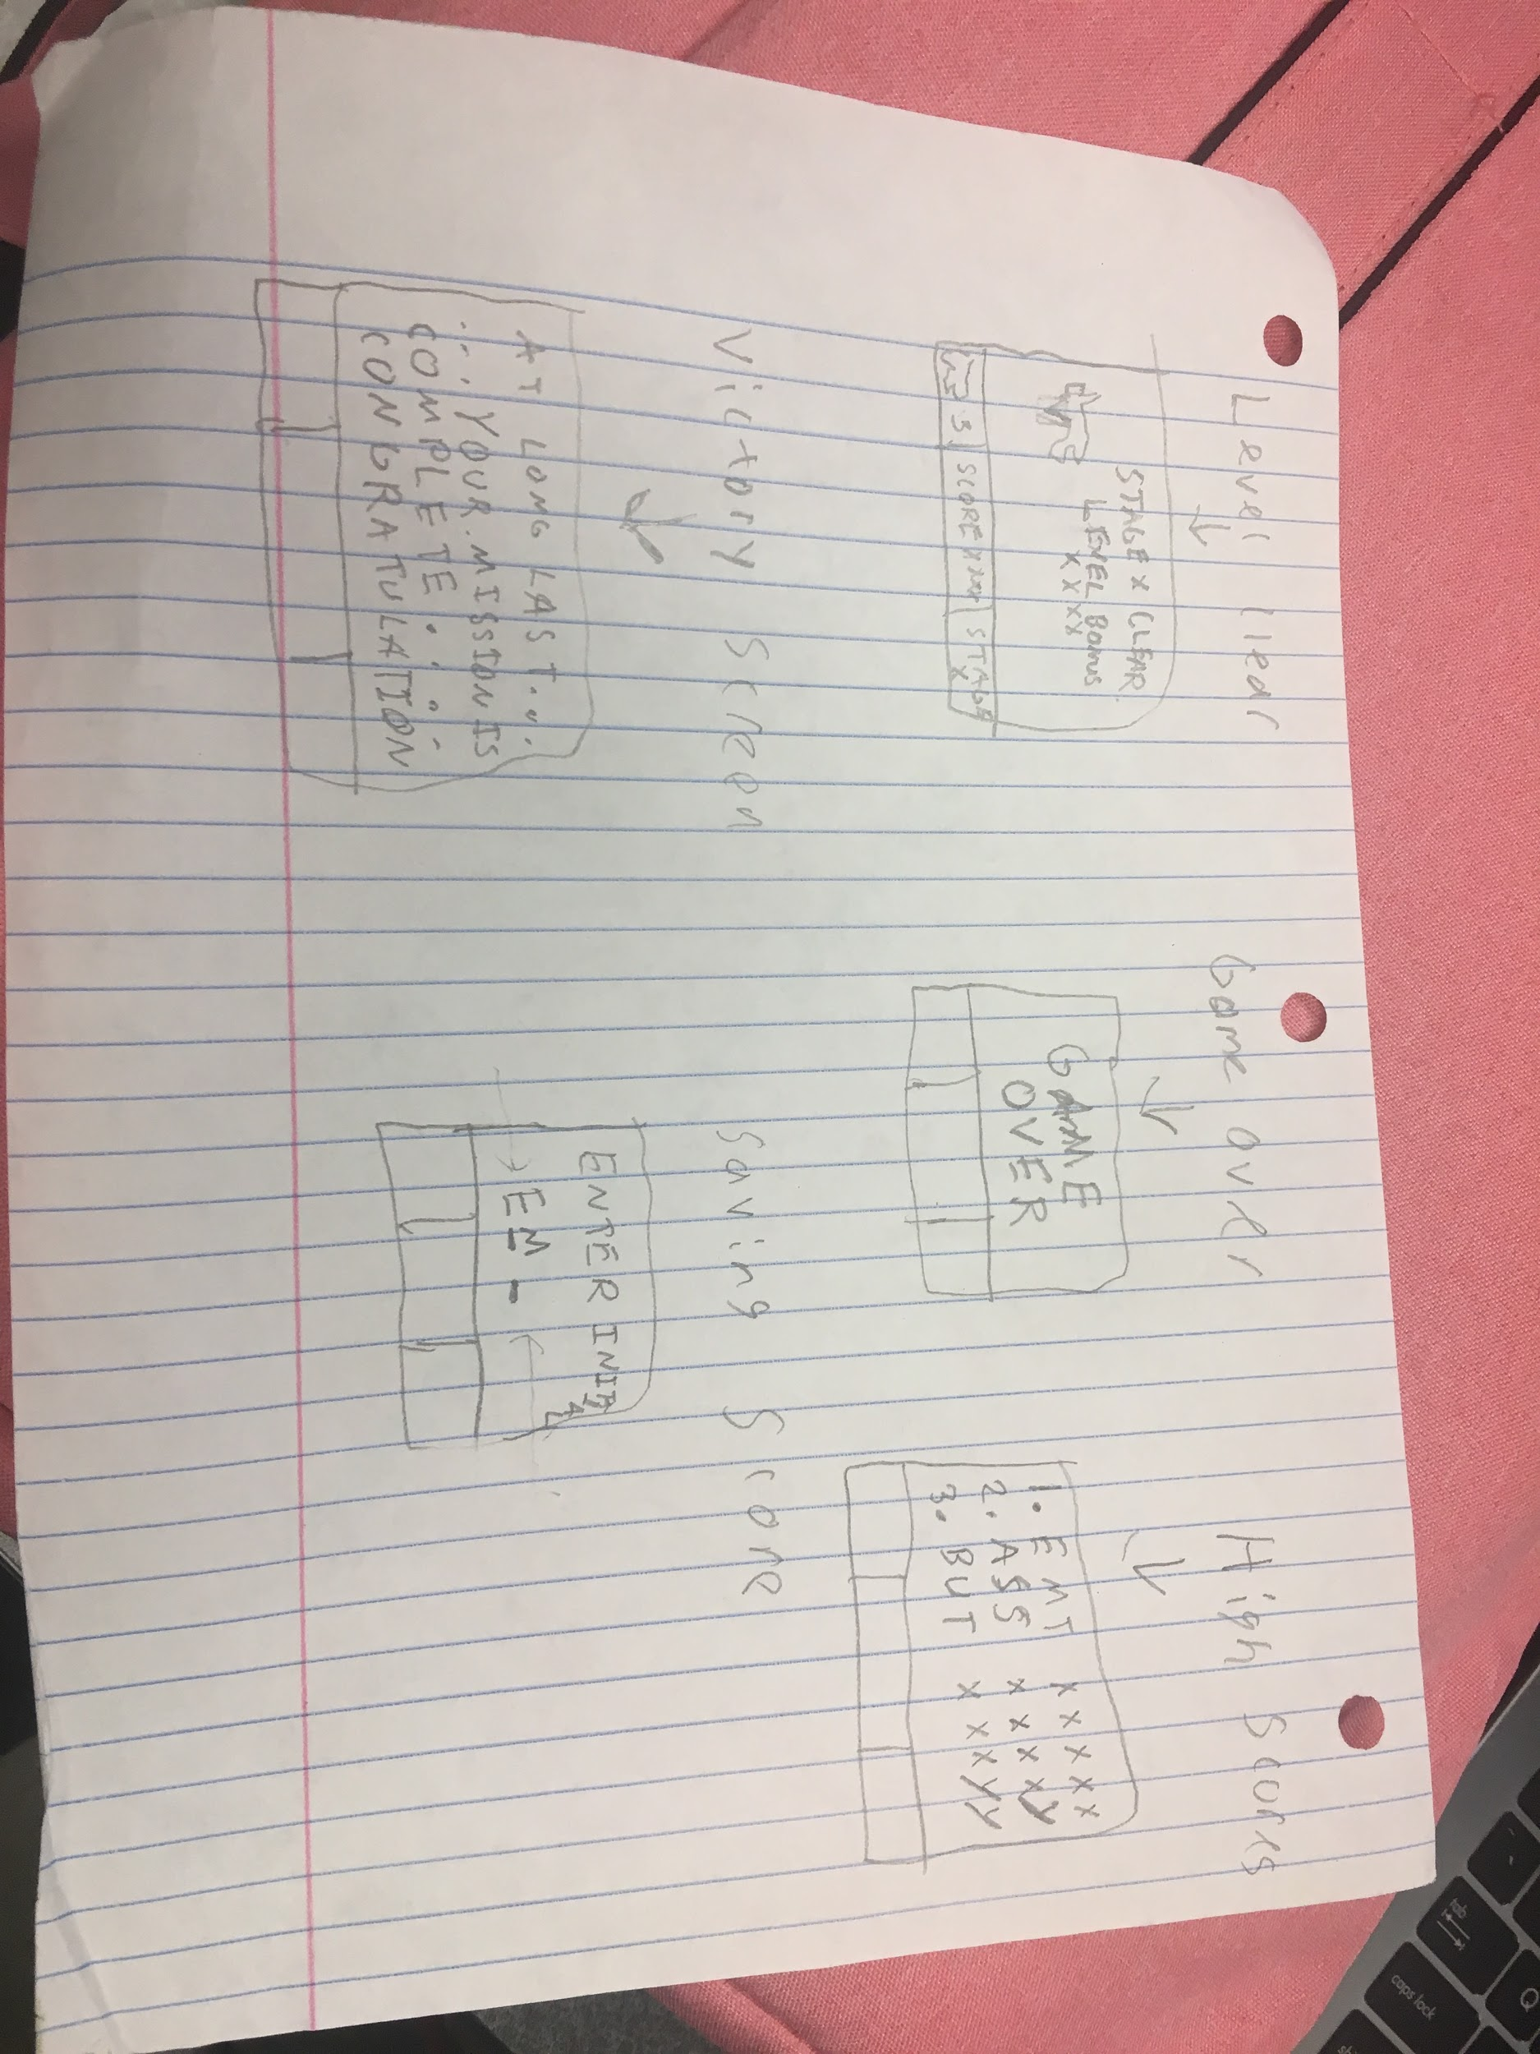

The above is a mock up of all the ui screens that occur in the game. The top left is the level clear screen. The screen turns black as a prompt saying what stage was cleared, and point bonus for clearing it. The player can still move around in the background. The game over screen appears when tries reach zero. It is a black screen saying “Game Over”. The victory screen on the bottom left shows the victory screen once the final stage has been finished. The screen to the right is saving the players score once their game is over. The last screen is the list of high scores. While it only shows three scores on here, it will show up to 10 scores.

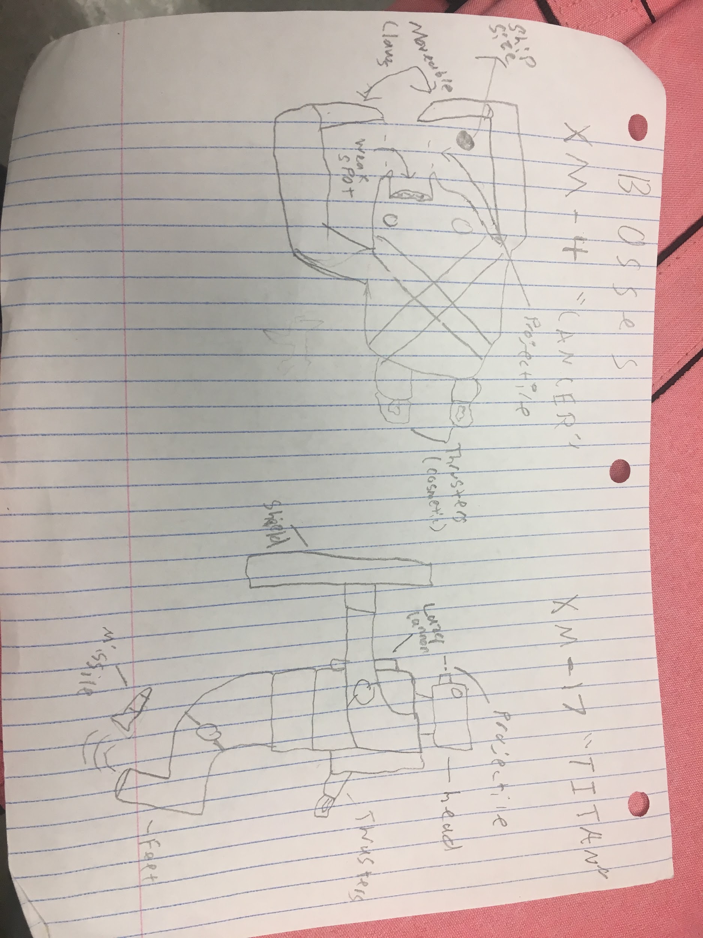

Above is the first two stages’ bosses. The left is the XM-4 Cancer, which has a crab like shape. It has arm like blades in the front, a mouth shape that fires projectiles from the points in the mouth, with eye lights, a cross pattern, with thrusters in the back. The crab will be a salmon color, with metal color highlights. The right boss is the XM-17 Titan. It should resemble a humanoid with legs, chest, arms, and head. It has a shield like the barrium enemy on its hand as well as a cannon on its chest and aesthetic thrusters on its back. It has a missle object it can fire from its foot as shown. The Titan should be deep green in color with a blue laser and projectiles. The missiles will be grey with red highlights.

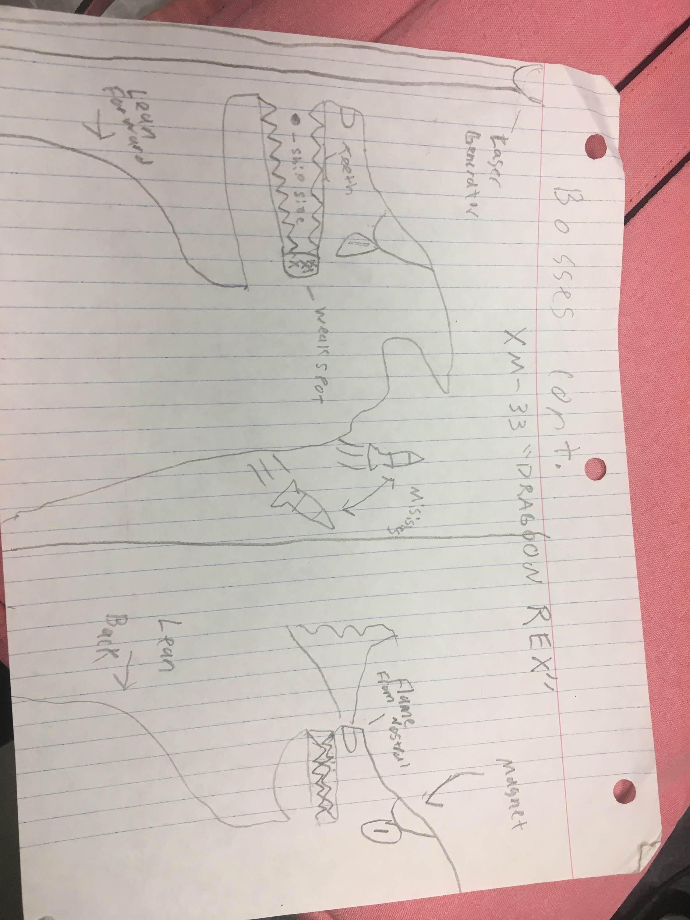

The above is the third stage boss, the Dragoon Rex. It has two phases it can be in, front facing with its mouth open (left image), and leaning back (right image) with mouth closed. In front facing mode, it can fire missiles like Titan did from its back (same size and look as those missiles). When leaning back, a flame from its nose will emit occasionally (orange color). It also has a magnet on its head that alters players movement so they cant avoid being destroyed as easy. There also will be a top laser that shoots down on the player (this will be a blue laser). The boss itself will be red with some highlights (like metal teeth and orange eyes).

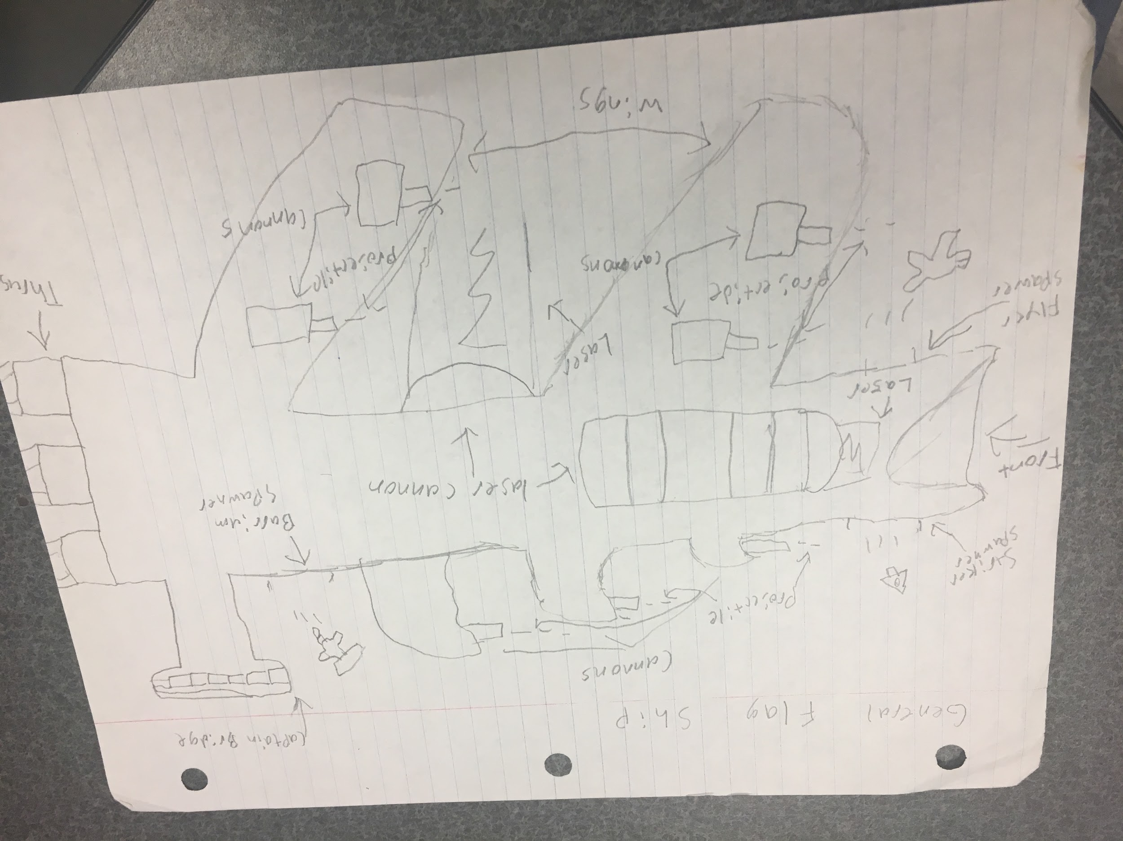

The above is the concept of the General Flag Ship. It has several projectile cannons on its wings and its top. It has two laser cannons; on its bottom and on the side visible to the player. The ship has three spawn points, which spawn a certain enemy at the player (flyer on bottom, striker on top front, and barrium near the Bridge). The sections of the wings and the bridge are destroyable as well as the main part of the ship (though that section will only be destroyed when the ship is destroyed). The ship will be a dark red with orange/yellow highlights to distinguish cannons and such.

# Sound

The basic theme throughout the game should be an upbeat, space sounding. The level themes can become more intense as one enters the boss or enter areas (like the colony section in stage 3).

The enemies don’t have sound but all projectiles should have small sounds. Lazers of all kinds should stand out in their sound (like a buzz noise). Explosions should be obvious, as well as other objects (like the Dragoon Rex’s flame snout).

Some chimes for upgrade should appear as well as jingles for ui screens (like victory screen, game over, game finished).

# 

# 2-Player Option

Normally, the game is played by one person. However, if in the main arcade hub the player sets up for multiplayer, the game will allow a 2 player mode.

In this mode, a second ship will appear as well as a second ui hub. Each player has their own try count as well as their own score. Each weapon on each ship has its own tag, so when one player destroys something, it only applies the score to that player, not both. Weapons upgrade only applies to the player that touched it.

Stage clear points go to both however, and both players will be saved and presented if the earned top ten score (though 2p mode has advantages to complete the game, it is a disadvantage to earning a high score due to players split score across the level).

# Development Plan

Each team has a responsibility to complete the game.

Team Uno

Developed this design document and ensure other teams follow it relatively accurately. Provide UI for the game that is affected by actions on the screen. Ensure that the game is playable from the arcade hub and that the scores from the game are visible in the arcade hub ui of the arcade game.

Team Code Crushers

Create all game objects and functionality in the game. Follow the mockup level plans to place object in right spots. Test all feature to ensure the game plays as it should. Will be in contact with team uno to make sure the game is playable from the arcade hub and meets expectations. Each level should be made with its object priority over others (don’t just make every object, just the ones that appear in the stage currently developing).

Team Dio

Develop the art, models, and the sounds of the game based on the design document. Some liberties based on capabilities will allow the team to make these criteria if they aren't one-to-one accurate with the design presented here. Must collaborate with team code crushers to ensure what models are needed for what objects at what time (follow stage by stage method).

Team Sad Networkers

Team is tasked with the network in the sub game. This means they are responsible with storing scores and the corresponding username for the game. They are also responsible for enabling a 2player mode for the game and ensure it plays correctly (scores are seperate, objects affect the specific player, etc.)